I can find the percent of an amount. I can find the new price of a product with a percentage discount.
Product  50% off | Original Price | Sale Price
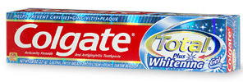  25% off | €2.80
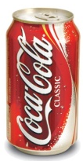  25% off | €0.80
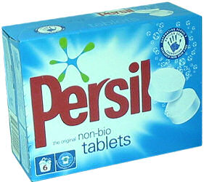  10% off | €10.44
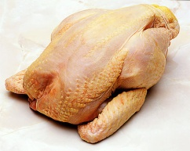 | €8.80
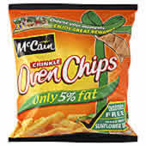  50% off | €5.50
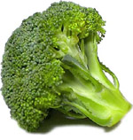  5% off | €2.00
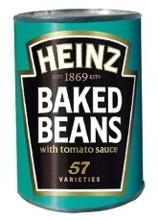  75% off  25% off | €1.28
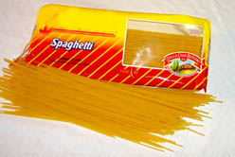  20% off | €1.60
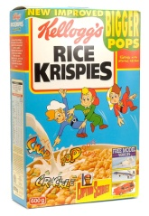 | €4.20
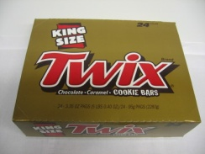  15% off | €12.60

Product  50% off | Original Price | Sale Price
25% off | €2.80 | €1.40
25% off | €0.80 | €0.60
10% off | €10.44 | €7.83
 | €8.80 | €7.92
50% off | €5.50 | €2.75
5% off | €2.00 | €1.90
75% off  25% off | €1.28 | €0.32
20% off | €1.60 | €1.20
 | €4.20 | €3.36
15% off | €12.60 | €10.71

Product  50% off | Original Price | Sale Price
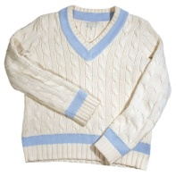  25% off | €35.00
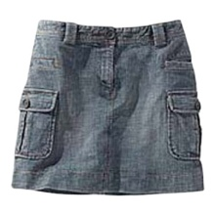  25% off | €27.00
 | €15.00
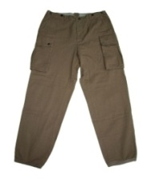  10% off  50% off | €19.90
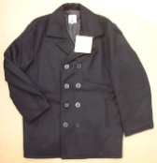 | €76.90
  5% off  75% off | €7.80
 | €23.60
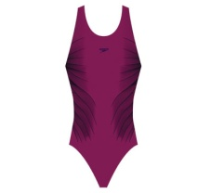  25% off  20% off | €35.40
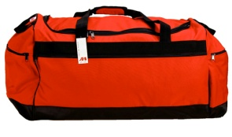 | €100.00
  15% off | €80.60

Product  50% off | Original Price | Sale Price
25% off | €35.00 | €17.50
25% off | €27.00 | €20.25
 | €15.00 | €11.25
10% off  50% off | €19.90 | €17.91
 | €76.90 | €38.45
5% off  75% off | €7.80 | €7.41
 | €23.60 | €5.90
25% off  20% off | €35.40 | €26.55
 | €100.00 | €80.00
15% off | €80.60 | €68.51

