Use your knowledge and understanding to solve these percentage problems. You can use a calculator. Don’t forget to show how you worked them out and check the units carefully!

1. 45% of ____ = 36m 11. 45% of ____ = 81mm

2. 35% of ____ = 7cm 12. 48% of ____ = 48ml

3. 62% of ____ = 124ml 13. 11% of ____ = £13.31

4. 24% of ____ = £21.60 14. 60% of ____ = 30 inches

5. 12% of ____ = 4.32l 15. 39% of ____ = £29.25

6. 15% of ____ = £2.25 16. 20% of ____ = 12kg

7. 20% of ____ = 12mm 17. 42% of ____ = 63g

8. 30% of ____ = 12km 18. 18% of ____ = 25.20l

9. 85% of ____ = £72.25 19. 27% of ____ = 51.30l

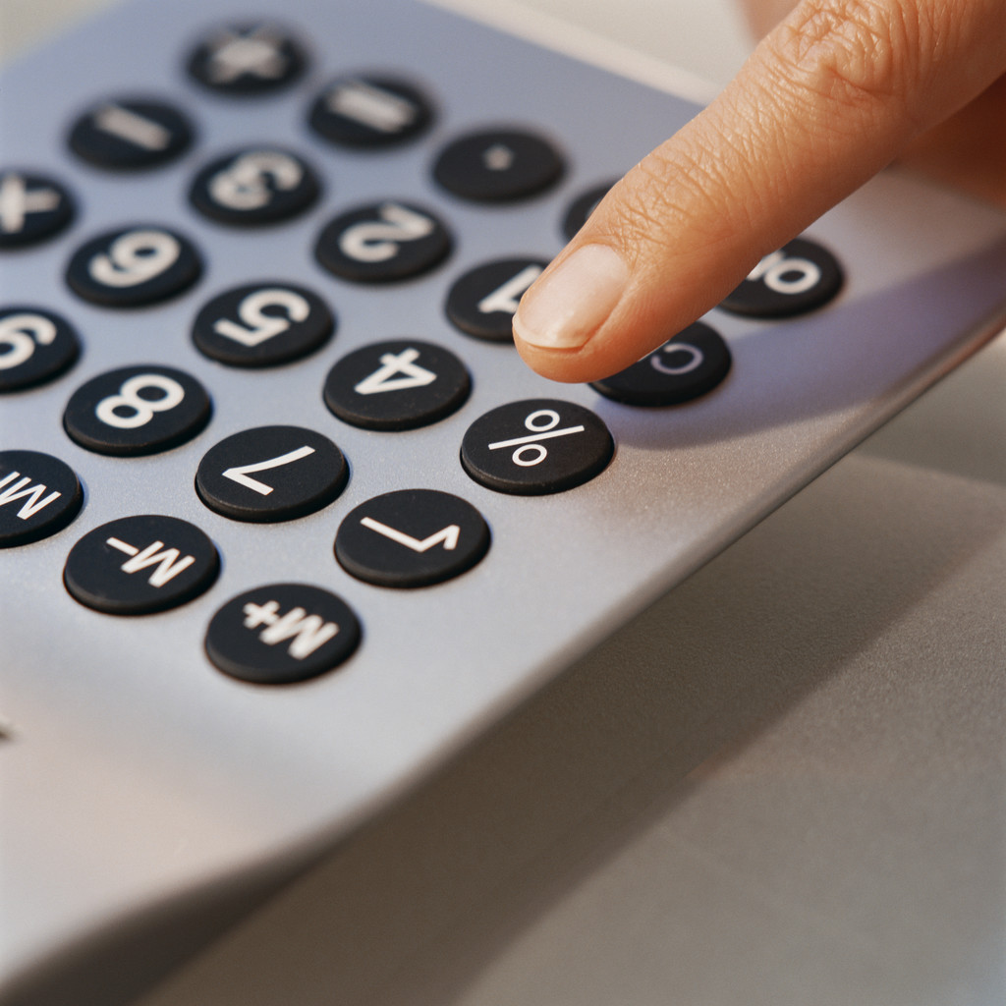
10. 55% of ____ = £44.55 20. 31% of ____ = £68.20

Use your knowledge and understanding to solve these percentage problems. You can use a calculator. Don’t forget to show how you worked them out and check the units carefully!

1. 45% of 80m = 36m 11. 45% of 180mm = 81mm

2. 35% of 20cm = 7cm 12. 48% of 100ml = 48ml

3. 62% of 200ml = 124ml 13. 11% of £121 = £13.31

4. 24% of £90 = £21.60 14. 60% of 50’’ = 30 inches

5. 12% of 36 l = 4.32 l 15. 39% of £75 = £29.25

6. 15% of £15 = £2.25 16. 20% of 60kg = 12kg

7. 20% of 60mm = 12mm 17. 42% of 150g = 63g

8. 30% of 40km = 12km 18. 18% of 140 l = 25.20 l

9. 85% of £85 = £72.25 19. 27% of 190 l = 51.30 l

10. 55% of £81 = £44.55 20. 31% of £220 = £68.20

