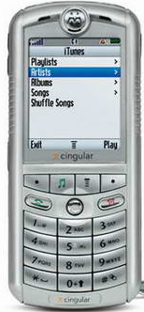
07946518263

Pick three numbers from the phone number above (for example 416)

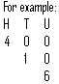
- Partition that number
H T U

- Write the number in words

- Write down 10 numbers from the phone number above which are a multiple of 5.

07946518263

Pick three numbers from the phone number above (for example 416)

- What is the largest number you can make with that number?

- What is the smallest number you can make with that number?

- Put these numbers in order, from largest to smallest
651, 826, 263, 465, 794

- Look at the example and complete the abacus to show the numbers
- 463
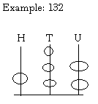
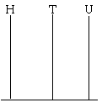

- 251

- Look at the partitioned numbers. Write the numbers in the correct boxes to show H, T and U.
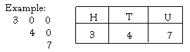

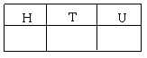

- 5 0 0
6 0
2
- 9 0 0
- 0
2
- 1 0 0
9 0
0

07946518263

Pick four numbers from the phone number above (for example 6419)
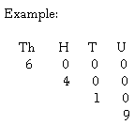
- Partition that number
Th H T U

- Write the number in words

- Write all the different numbers you can make with your number
For example 6419 = 6491, 6149, 6194, 6941, 6914, 4619, 4691, 4169, 4196, 4916, 4961, 1649, 1694, 1964, 1946...

Your Turn!!!
Now you write a phone number and pick some numbers from it.

You can partition the numbers and/or make different numbers to find the biggest and smallest number. You can find multiples of 2 and/or 5. It’s up to you but write your work below!!

07946518263

Pick two numbers from the phone number above (for example 19)

- Partition that number
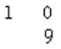
T U

- Write the number in words

- Put these numbers in order from smallest to biggest
10, 24, 76, 23, 5

- Pick a three digit number from the phone number

- How many different numbers can you make with that number? For example 354 = 345, 534, 543, 435, 453

- Put these numbers in order from smallest to biggest
101, 650, 345, 888, 340

07946518263

Pick four numbers from the phone number above (for example 6419)
- Partition that number
Th H T U

- Write the number in words

- What odd numbers can you make from your number?
Example: 6419 = 1, 9, 19, 61, 69, 91, 169, 149 etc

- What even numbers can you make from your number?
Example: 6419 = 4, 6, 14, 16, 46, 64, 94, 96, 146, 194, 196 etc

- Partition these numbers:
- 5320 (b.) 9175
Th H T U Th H T U

- 6291
Th H T U

- Write down the value of the underlined digit:
- 4658

- 1390

- 27.32

- Place these decimals in the correct order, from largest to smallest:
- 1.98, 5.65, 12.40, 0.05, 5.66

- 7.85, 0.5, 0.25, 0.75, 1.20, 0.02, 1.25

Your Turn!!!
Now you write a phone number and pick some numbers from it.

You can partition the numbers and/or make different numbers to find the biggest and smallest number. You can find multiples of 2 and/or 5. It’s up to you but write your work below!!

07946518263

Pick four numbers from the phone number above (for example 6419)
- Write the number in words

- Partition the number
Th H T U

- Put these numbers in order from smallest to biggest
435, 1001, 678, 4567, 326

- Write down the value of the underlined digit
- 345

- 690

- 705

