PIRATE VENN DIAGRAM

Has 1 leg

Has a
beard

Has a parrot.

Use the pictures below to fill in this diagram.

One-eyed Jack Captain Splat Old Pete

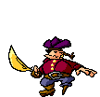
Carlos Little Tim Peg Leg Captain Skuller Young Nick

