Name Date

LOFT: to write fractions
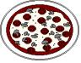

= 1 whole pizza =

How many parts has this pizza been cut into?

Colour in 1 part.

Write this as a fraction.

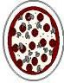
How many parts has this pizza been cut into?

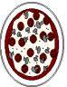
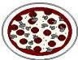
Colour in 3 parts.

Write this as a fraction.

Use a ruler and pencil to cut this pizza into 8 parts.

Colour in 5 parts.

Write this a fraction.

Cut this pizza into 4 parts.

Colour in 2 parts

Write this as a fraction.

