LI: I can use relevant vocabulary to describe position.
Cut out the 4 pictures at the bottom of the page and stick them into an empty space on the grid. Then answer the questions on the next page.
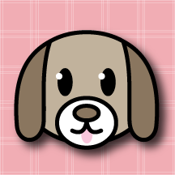  dog |  | square | rabbit
 | bear | duck | hen
rectangle | elephant |  | circle
sheep | triangle | 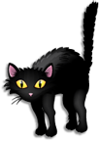  cat

cow | star | girl | boy
Name____________ Class____ Date________
LI: I can use relevant vocabulary to describe position.
Fill in the blanks using the new vocabulary below.
- The elephant is _________ the triangle.
- The rabbit is _________ the hen.
- The triangle is _________ the sheep and the cat.
- The square is _______ ___ the rabbit.
- The cow is ______________the _____________.
- The star is ______________ the _____________.
- The girl is ______________ the _____________.
- The boy is ______________ the _____________.

above below next to between

under right left

