£ s d or Pounds, Shillings and Pence –
The money used in the years before 15 February 1971.

“These were the coins and notes that we used in my childhood,” says Mr. Welburn nostalgically: half-penny (haypenny), one penny, three-penny (thripnny bit), six-penny (tanner), shilling (bob), two shilling (2 bob), half-a-crown (arf-crown), a crown, 10 shilling note (10-bob) 1 pound note (a note).

- £1 = 20 shillings (or ‘bobs’) or 240d (pennies)
- 10 bob note = ½£ = ____ shillings (s) or _______d
- A bob = 1 shilling(s) or ____d
- Crown = 5 shillings or ______ d (pennies)
- Half-a-crown = 2½ s or ______ d
- 2 bob = ___ s or 24d (pennies)
- A tanner = ½ a bob = ___d
- Remember there were 240 pennies in a pound
- So, how many half-pennies or ‘haypennies’ were in a pound? (2 half-pennies = 1 penny)
- How many ‘thripnny bits’ were in pound?

ANSWERS:
If you have worked out that there were:
- 10 shillings or 120 pennies in a 10 bob note
- 5 shillings or 60 d (pennies) in a crown
- 2½ s or 30d in a half-a-crown
- 2 bob = 2s or 24d (pennies)
- A bob = 1s or 12d
- A tanner = ½ a bob = 6d
- 480 ‘haypennies’ were in a pound?
- 80 ‘thripnies’ were in pound?
You can now workout how many 3d (thripnnies) in:
(think, 4 3d or thripnny bits = a bob)
- 10bob
- 3 tanners
- A half crown
- 3 bob
- 12 shillings
- 3 crowns

You can now workout how many 6d (tanners) in:
- 4 bob
- a 10 bob and a half crown
- £1 2s 6d pronounced – one pound, 2 (shillings) and 6 (pennies)

If you now know how many shillings make a pound (20) and how many pennies make a shilling (12), can you add the following:

- 2s 6d and 3s 6d = ________
- 5s and 1s 6d = _______
- £1 3s 3d and £2 4s 6d = __________
- £3 14s 9d and £4 5s 3d = __________
Now can you work out what would the least number of coins that would be used to represent:
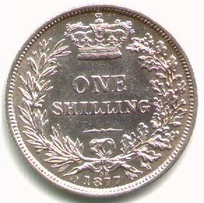
- 15s 6d
- 7s 9d
- 21s 13d
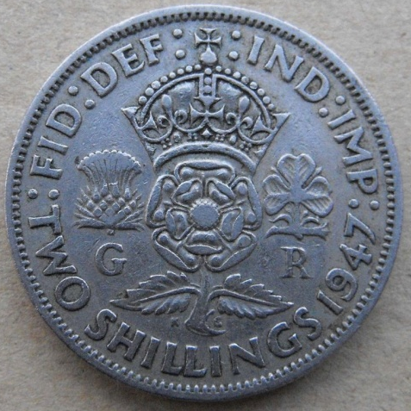
- £2 3s 11d
