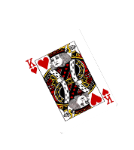
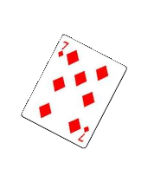
Names:_________________________
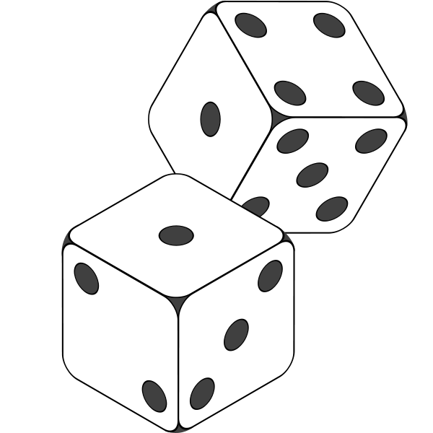
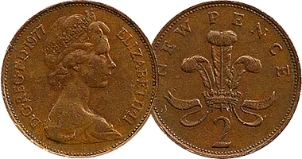
Probability
Activity 1
Tossing a coin
The probability of tossing a ‘head’ is

The probability of tossing a ‘tail’ is
Try it:
 | Tally | Total
Heads
Tails

Activity 2
Cubes in a bag
The probability of picking a blue cube is

The probability of picking a red cube is
Try it:
 | Tally | Total
Blue
Red

Activity 3
Throwing a die
The probability of throwing any of the numbers is a
Try it:
 | Tally | Total
1
2
3
4
5
6

Activity 4
Picking a Card

You have four playing cards. Think of some probability questions of your own to ask about the cards. eg
What is the probability of picking a ___________?
Work out the probability fraction of your question.
Fill in the tally chart below to record your findings.
If you have time, think of two more questions.

The probability of ________________________________ is a ________

 | Tally | Total

The probability of ________________________________ is a ________

 | Tally | Total

The probability of ________________________________ is a ________

 | Tally | Total

