Impossible

Unlikely

Likely

Certain
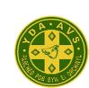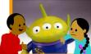
You will go to Amman Valley School in September.
You will meet an alien on your way home.
You will eat lunch today.

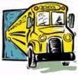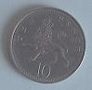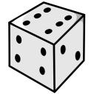
You will travel home from school by bus today.
You will get a tails when you toss a coin.
You will roll a 6 on the dice.

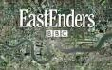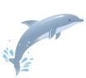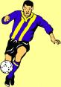
You will see a dolphin in the swimming pool.
You will become a famous footballer.

Eastenders will be on TV tonight.

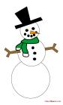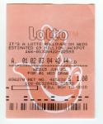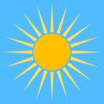
It will snow tomorrow.
You will win the National Lottery this Saturday.
It will be sunny tomorrow.

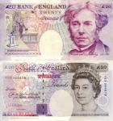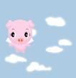
You will find two £20 notes on the way home from school.
You will see a flying pig in Ammanford.

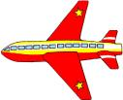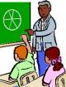
You will have another maths lesson this week.
You will travel by plane somewhere this year.

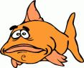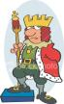
You will win a goldfish at the fair.
You will read at least 6 books this term.
You will become King one day.

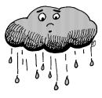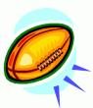
It will rain one day this week.
Wales will win the next 6 nations grandslam.
You will become a famous singer when you are older.

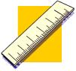

You will use a ruler in school today.

