It will snow tomorrow. | I will drive my parent’s car later. | 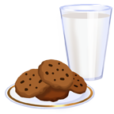I will eat something today. | I will watch TV tonight.
I will fly next week. | I will go to the Moon one day. | It will be dark tonight. | I will see a dragon in the playground this week.
Argos will give away all their PS2 games tomorrow. | Mrs. Allen will turn into a mermaid if she gets wet. | 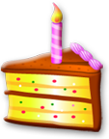I won’t have a birthday next year. | I will be famous one day.
It will snow tomorrow. | I will drive my parent’s car later. | I will eat something today. | I will watch TV tonight.
I will fly next week. | I will go to the Moon one day. | It will be dark tonight. | I will see a dragon in the playground this week.
Argos will give away all their PS2 games tomorrow. | Mrs. Allen will turn into a mermaid if she gets wet. | I won’t have a birthday next year. | I will be famous one day.

