Summative Test – Ratios
1/ If there are 15 boys and 19 girls in year 6, what is the ratio of boys to girls? …………………………

2/ In a zoo there are 50 kangaroos and 32 monkeys. Show the ratio of kangaroos to monkeys. ………………………

3/ What would the ratio above be in its simplest form? …………………………

4/ Write the ratio of shaded to un-shaded for the following shapes:
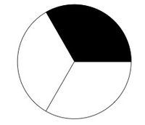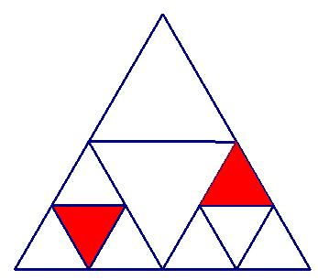
Ratio ……………… Ratio …………………. Ratio …………………

4/ Simplify the following ratios 10:5 ………………………..
20:5 ………………………..
30:10 ………………………..

5/ Express as a ratio in its simplest form (remember to make the units the same)
10cm to 2m ………………………….
40 seconds to 5 minutes …..……………………..
15 minutes to 6 hours ………………………….
350g to 7kg ………………………….

6/ Circle true or false to state whether the following ratios are equivalent ratios
2:3 and 4:6 are equivalent (true/false)
7:1 and 2:5 are equivalent (true/false)
4:1 and 8:3 are equivalent (true/false)
75:25 and 3:1 are equivalent (true/false)

7/ Three equivalent ratios for the ratio 5:8 could be 10:16, 15:24 or 50:80
Write three equivalent ratios for each of the following ratios.

2:3 ……………………. ……………………… …………………….
3:9 …………………… …………………….. …………………….

8/ A bag of chocolates contains 18 chocolates. They are divided between Sam and Nick 2:1
What fraction does Nick receive? ………………………
What fraction does Sam receive? ………………………
How many chocolates does Nick receive? ……………………...
How many chocolates does Sam receive? ……………………….

