Scorer of the Year!

This is the amount of goals that a footballer scores in one season.

- Round these scores to the nearest 10 goals:

Footballer | Goals scored | Rounded to the nearest 10
Wayne Rooney | 77
Frank Lampard | 69
Emmanuel Adebayor | 54
Leon Best | 43
Andrew Johnson | 35
Daniel Sturridge | 22

This is the amount of skips 4H achieved in one minute during the sponsored skip.

- Round these scores to the nearest 100:

Name | Skips | Rounded to the nearest 100
Kayleigh | 482
Hannah | 411
Aimee | 328
Maisey | 249
Rose | 117
Laura | 50

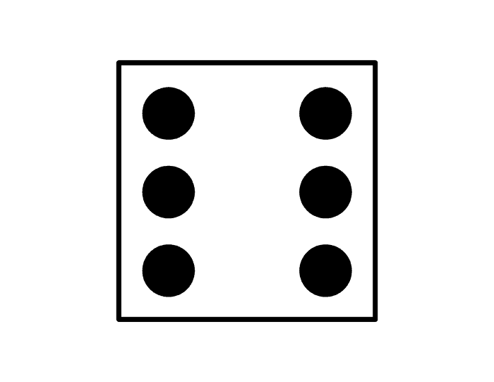

Now try this:

Roll the three dice and make a two digit number
For example: 636.
Round the number to the nearest 100 and repeat.

