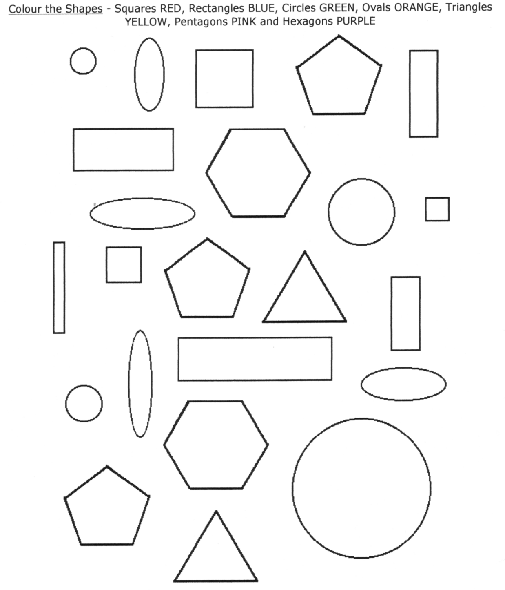

Colour the squares red. The circles blue. The rectangles green. The triangles yellow. The ovals purple. The pentagons pink. The hexagons orange.

