START | 1 curved face.  Rolls in any direction.  0 vertices. |  | 6 flat, rectangular faces.  8 vertices.  12 edges.
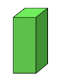 | 4 triangular faces.  1 square face.  5 vertices. | 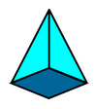 | 1 flat, circular face  1 curved face.  Rolls in circle
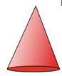 | 5 flat faces.  9 straight edges.  3 rectangle faces. | 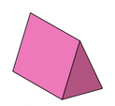 | 8 vertices.  12 straight edges.  6 square faces.
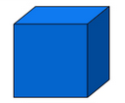 | 2 circular faces.  2 curved edges.  Rolls in a line | 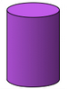 | 4 vertices.  6 straight edges.  4 triangular faces.
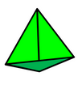 | 1 flat, circular face.  1 curved face.  0 vertices. | 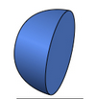 | END

