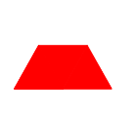
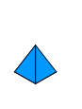
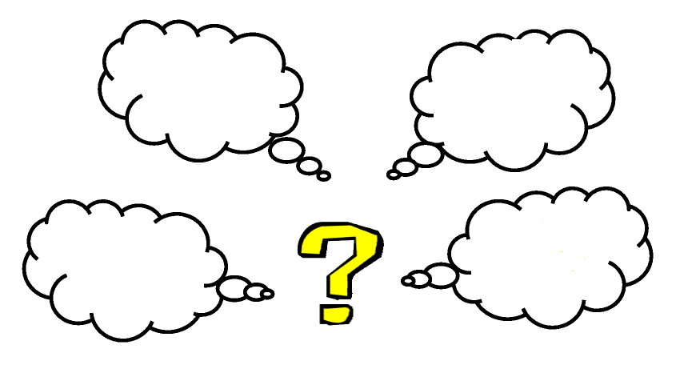

September 2010

Progression
Within Shape
Angles
Properties
2D Shape
3D Shape
Introduction

Shape and space (also known as geometry) is the study of two- and three-dimensional objects and their properties. It involves understanding properties of angles, lines, reflection, rotation and enlargement.

A particularly important aspect of Shape and space is the idea of proof. It is proof that distinguishes mathematics from the sciences. Children first meet a proof in Year 8 when they are shown the proof that the angles of a triangle add up to 180°.

Shape and space has clear links within mathematics to ratio and proportion (similar shapes), and to other subjects such as design with scale drawing, science with growth, and geography with maps and scales.

Someone who has a good understanding of Shape and Space is likely to have good 'spatial awareness'. This will help in everyday life (driving, do-it-yourself, reading maps and most sports). Good spatial awareness is essential in many jobs, for example: building, architecture, engineering and fashion design.

2D Shape Progression | 3D Shape Progression
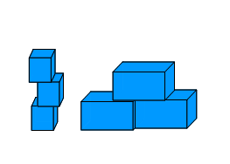    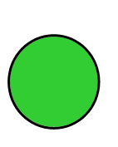  Small  To know the properties of 2D Shapes  Big | To know the properties of 3D Shapes  Stack  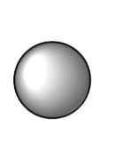  Roll
To know the names of 2D shapes  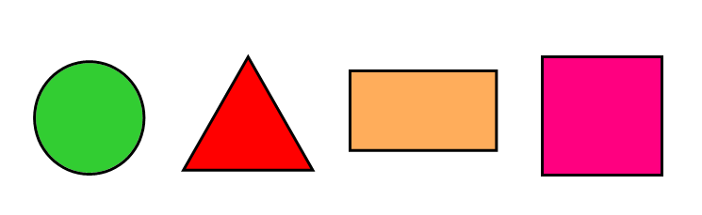    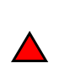  Circle Triangle Rectangle Square | 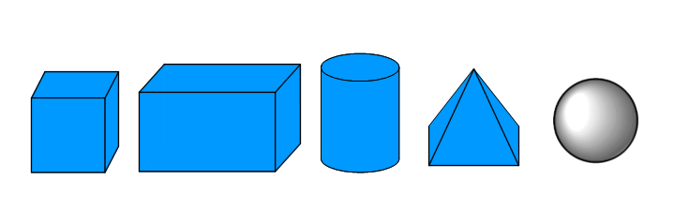  Cylinder Sphere  Cube Cuboid Pyramid  To be able to name 3D shapes
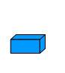  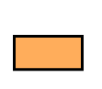    Rectangle  4 sides  4 corners  Square  4 sides  4 corners  Triangle  3 Sides  3 Corners  Circle  No Sides  No Corners  To know more properties of 2D shapes | To know the properties of a 3D shape  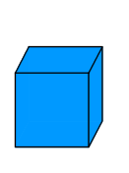  Cube – 6 face, 12 edges, 8 corners    Cuboid - 6 face, 12 edges, 8 corners  Cylinder - 3 face, 2 edges, 0 corners  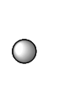  Pyramid - 4 face, 6 edges, 4 corners  Sphere - 1 face, 0 edges, 0 corners
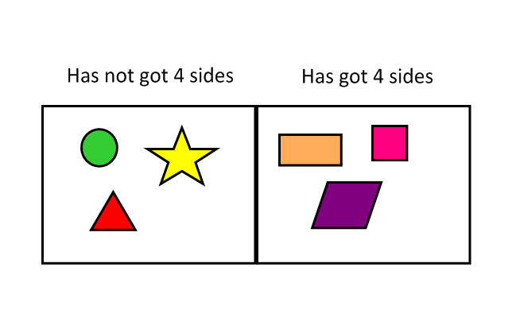
To be able to sort shapes using one criterion
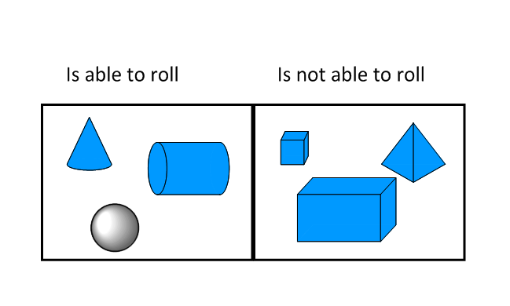

Can a child recognise differences between the two types of shapes?
Remember: Different sizes of shapes still have the same properties

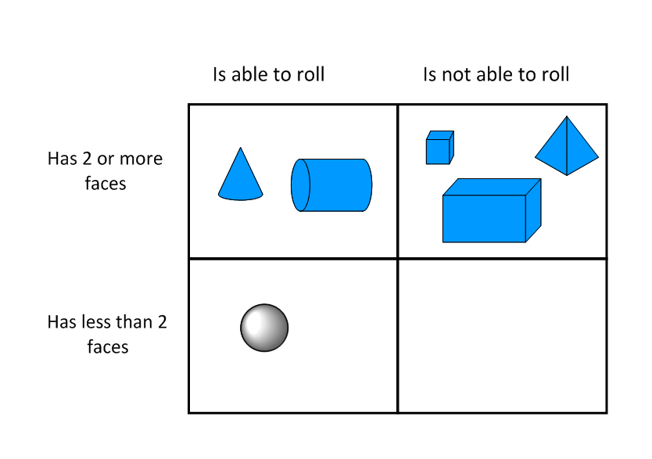
To be able to sort shapes using more than one criteria

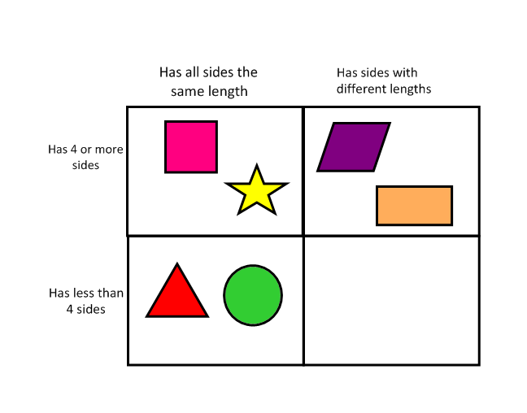

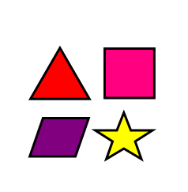
Regular - all sides the same  length  To understand the term regular and irregular  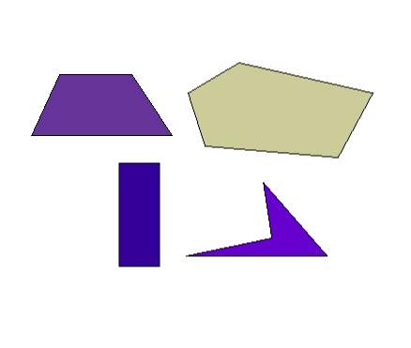  Irregular - 1 or more sides  With a different length to  the others | To be able to recognise common 3D Shapes  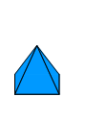  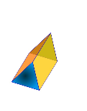  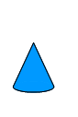  Cone  Triangular Prism  Square-based Pyramid
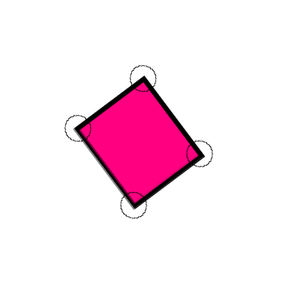
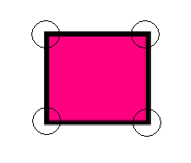

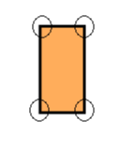

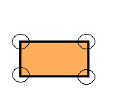
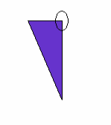

To be able to recognise right angles in shapes

To be able to recognise angles bigger
or smaller than 90º
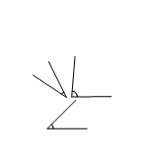

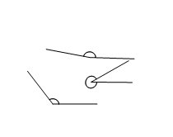
Acute Angles – Angles smaller
than 90º

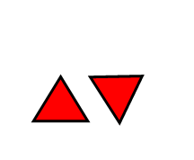
Obtuse Angles – Angles
bigger than 90º

Equilateral triangle –
All sides the same length

Recognise Right-Angled and Equilateral Triangles
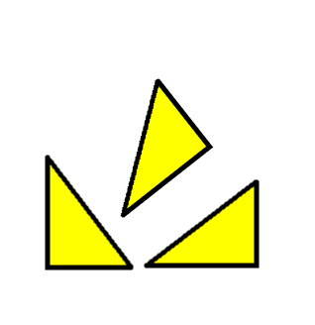

Right Angled Triangles –
Triangle with a Right -
Angle in them

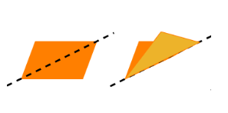  Demonstrate Reflective Symmetry by folding  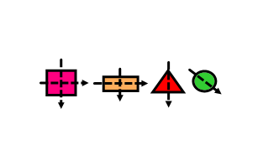 | Relate 3d shapes to photo of 3d objects from different viewpoints.  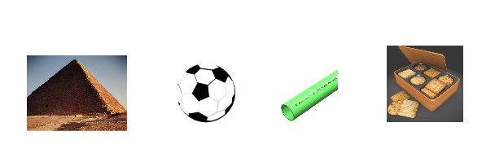  Pyramid Sphere Drainpipe Cuboid  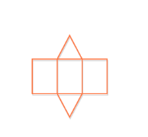
Recognise nets of 3D shapes
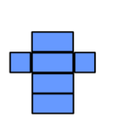


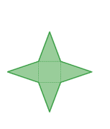
Triangular Prism

Cube
Cuboid

Square based Pyramid

Use the properties of 2d and 3d shapes


Rhombus


Trapezium

Parallelogram

Recognise names of most quadrilaterals

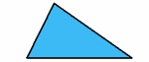
Scalene – All the sides are
different lengths
Recognise different types of Triangles

Equilateral –
All sides the same length

Right Angled – A triangle with
a right-angle

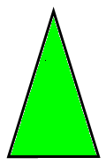 Isosceles – 2 sides the
Length

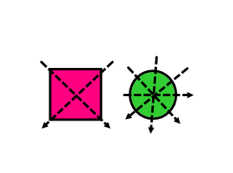
Recognise an oblique line of symmetry

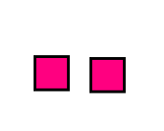
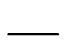

Horizontal

Vertical
Congruent – Same shape and size

Use more technical mathematical terms

Understand that a Square is also a Rectangle    Rectangles must have:  - 4 Sides  - 4 right angles  - Opposite sides are equal & parallel    - Diagonals that bisect each other  Squares must also have:  - All 4 sides equal  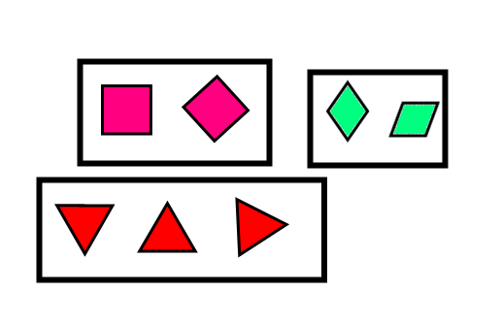  - Diagonals cross at right angles | 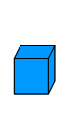
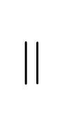
Visualise shapes in different orientations
Understand the terms Parallel & Perpendicular …..
Perpendicular– 2 lines meeting at 90º
Parallel – 2 lines running side by side never meeting

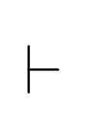

… in relation to 2D Shapes
Perpendicular faces meeting at 90º
Faces running parallel
Edges running parallel & meeting at 90º

… in relation to Edges & Faces
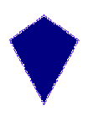
Parallelogram
4 x sides, 4 x corners,
2 x parallel lines
1 x sides same length
Kite
4 x sides, 4 x corners,
0 x of parallel lines
Trapezium -
4 x sides, 4 x corners,
1 x sides same length,
1 x parallel sides

Classify quadrilaterals in more detail

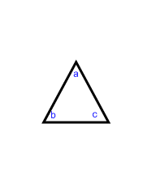
Know the sum of all angles in a triangle

The sum of all the angles inside a
triangle is ALWAYS 180º

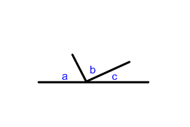
This can be written as a + b + c = 180º

The sum of all angles on a
line is ALWAYS 180º

This can be written as a + b + c = 180º

Know the sum angles on a straight-line or around a point

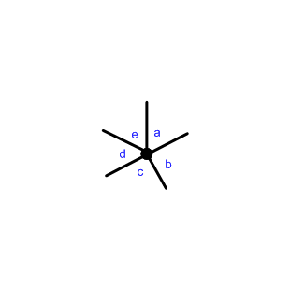

The sum of all angles around a point is ALWAYS 360º

This can be written as a + b + c +d + e = 360º

