Girl’s World
Lucy has been given money for her birthday and she wants to buy a new outfit. She can only spend £25 on the whole outfit.
- Create outfit ideas for Lucy. Draw the outfits with price labels.
- Show the total cost.
- Show how much change she would get.
- With which outfit would she receive the most change and how much would this be?

 | 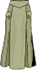 |  |  |  |  |  | 
£9.75 | £12.95 | £8.89 | £6.73 | £8.53 | £6.48 | £9.67 | £11.97
 |  |  |  | 
£12.65 | £9.69 | £14.83 | £16.34 | £7.25

Nigel’s Newsagents
Danny is having a party and wants to give his guests a party bag each containing 4 items. He can only spend £2 per person.
- Create party bag ideas. Draw the bag with price labels.
- Show the total cost.
- Show how much change he would get.
- With which bag would he receive the most change and how much would this be?

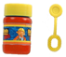 |  | 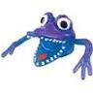 | 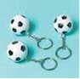 |  | 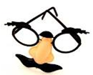 | 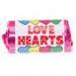 | 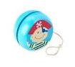
25p | 38p | 29p | 17p | 43p | 72p | 19p | 65p
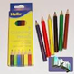 | 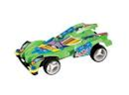 | 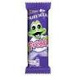 |  | 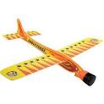 | 
89p | 48p | 18p | 27p | 58p | 77p

