Division

- There are 10 birds in a tree. They need to live in 2 nests, with the same number in each nest.
Divide the birds below into 2 groups.

Now finish this sum. 10 ÷ 2 =

- You have 9 sweets in a bag and you want to share them equally between 3 friends.
Circle these 9 sweets into 3 groups.

Now finish the sum. 9 ÷ 3 =

- A pizza is cut into 6 pieces. You want to share the pizza with your Dad. How many pieces would you both have? Use the picture to help you.
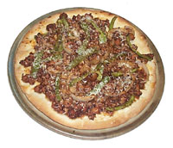

Now finish the sum. 6 ÷ 2 =

- There are 8 fish that need putting into 4 tanks. How many fish in each tank?
Write the sum for this question.

