

If one car has 4 wheels how many wheels are there altogether with 5 cars?



If 1 bird has 2 wings how many will 6 have altogether?

If there are 5 sweets in 1 jar how many will be in 4 jars altogether?

If 1 ant has 6 legs ho many will 3 have altogether?


If 1 bunch of flowers ha 10 roses how many will 6 bunches have altogether?

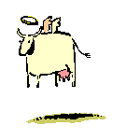
If a farmer has 7 fields and puts 5 cows in each field how many cows will there be?

