Translation

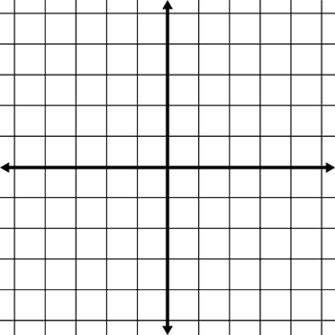
Move 5 units left
Move 6 units down
Move 4 units down
Move 6 units right
A
B
C
D
A
B
C
A
B
C
D
A
B
C
L.O: To be able to draw the position of a shape after translation.

Move 6 units right
Move 7 units left and 6 units up
Move 6 units left and 6 units down
Move 7 units left and 6 units up
A
B
C
D
A
B
C
A
B
C
D
A
B
C

