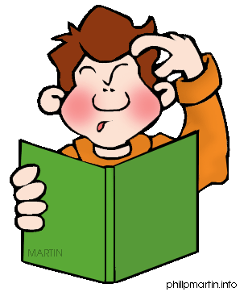
Square Group

One step problems – show all your working out. Remember RUCSAC.
A)
- One bag of sweets has 35 sweets in it, the other 42. How many sweets are there altogether?

- One bag of sweets has 25 sweets in it, the other 46. How many sweets are there altogether?

- I have 55 comics and I lend 23 to my friend. How many do I have left?

- I have 78 comics and I lend 26 to my friend. How many do I have left?

- I have 47 comics and I lend 34 to my friend. How many do I have left?

- I have 52 comics and I lend 26 to my friend. How many do I have left?

- I save 39p one week and 24p the next week. How much money have I saved in total?

Two Steps
B)
- On a school trip 56 people visit a museum. There are 45 children and 4 teachers, the rest are parents. How many parents are there?

- On a school trip 72 people visit a museum. There are 53 children and 7 teachers, the rest are parents. How many parents are there?

- In a week John saves £1.75, on Monday he has 55p on Wednesday 75p. How much does he save the rest of the week?


Circle Group

One step problems – show all your working out. Remember RUCSAC.
A)
- One bag of sweets has 35 sweets in it, the other 42. How many sweets are there altogether?

- I have 47 comics and I lend 34 to my friend. How many do I have left?

- I have 52 comics and I lend 26 to my friend. How many do I have left?

- I save 39p one week and 24p the next week. How much money have I saved in total?

Two Steps
B)
- On a school trip 72 people visit a museum. There are 53 children and 7 teachers, the rest are parents. How many parents are there?

- In a week John saves £1.75, on Monday he has 55p on Wednesday 75p. How much does he save the rest of the week?

- At a recent clean up of the playground. The 3 children collected 96 pieces of rubbish. Louis collects 34 pieces, Oliver 26 so how many has Charlie collected?

- The Y4 teachers have 140 biscuits in the staff room. Miss Merrie eats 41, Ms York eats 55, how many does Mrs Cowen eat?


- Zahra has 123 comics she lends 46 to Kristjana and 56 to Alice, how many does she have left?

Triangle Group

One step problems – show all your working out. Remember RUCSAC.
A)
- Tilly has £23, Jack has £1.25 and Jamie has 56p. How much do they have altogether?

- Claudia has 142 comics and she lend 64 to Cole. How many does she have left?

- Caitlin save 1.39p one week, 38p the next week and 12.04p the final week. How much money does she save in total?

Two Steps
B)
- On a school trip 272 people visit a museum. There are 223 children and 16 teachers, the rest are parents. How many parents are there?

- In a week Daniel saves £5.75, on Monday he has 255p on Wednesday 175p. How much does he save the rest of the week?

- At a recent clean up of the playground. The 3 children collected 196 pieces of rubbish. Alex collects 64 pieces, Dan 73 so how many has Joe collected?

- The Y4 teachers have 234 biscuits in the staff room. Miss Merrie eats 91, Ms York eats 75, how many does Mrs Cowen eat?

- Bronwen has 523 comics she lends 246 to Caitlin and 156 to Alex, how many does she have left?

- Owen has one 50p coin and four 20p coins. He buys a melon for 47p and 2 grapefruits for 15p each. How much money does he have left?

