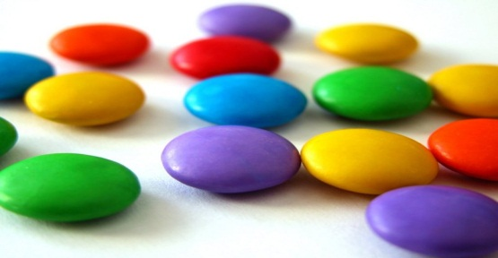
Ratio and proportion with Smarties
I have a tube with 24 smarties in it. They are coloured as follows:
3 green 2 blue 4 yellow 6 orange
1 brown 1 purple 6 pink 1 red
What is the ratio of orange to blue smarties?
What is the ratio of green to pink?
If you compared every colour to every other colour, How many different ratios could there be in total?
Explain how you worked this out.
Now, can you express each colour as a proportion of the total?
Ratio and proportion with Smarties

I have a tube with 24 smarties in it. They are coloured as follows:
3 green 2 blue 4 yellow 6 orange
1 brown 1 purple 6 pink 1 red
What is the ratio of orange to blue smarties?
What is the ratio of green to pink?
If you compared every colour to every other colour, How many different ratios could there be in total?
Explain how you worked this out.
Now, can you express each colour as a proportion of the total?

