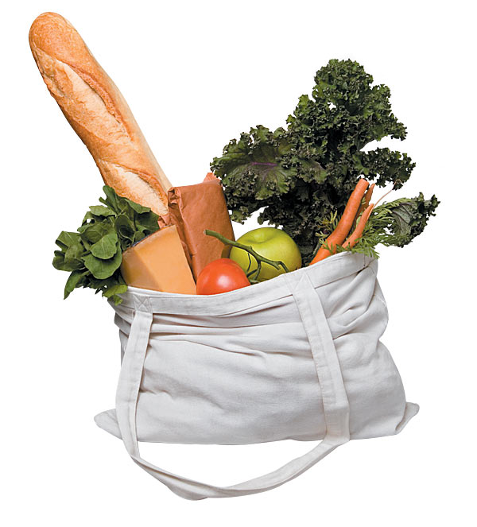
Supermarket Mayhem

As a group you need to help out the supermarket manager by solving the following problems.

- Order the groceries from smallest weight to largest.

- Which is the heaviest item?

- Which is the lightest item?

- What are the total weights of:

a. The Mini Cheddars and the Hovis bread?
b. The Frosties and the Muller Corner?
c. The Eggs and the Dairy Chocolate?

- What item weighs more than 1kg?

- What two items weigh the same?

- Multiply the weights of these items:

- Mini Cheddars x5
- Hovis bread x2
- Eggs x3
- Muller Corner x2
