Telling the Time
Look at the written time, can you draw the hands on the clock and write the digital time?
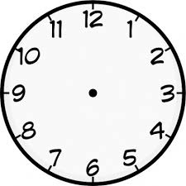

:
:
:

10 to 3 quarter past 5 half past 3

:
:
:

25 to 6 5 past 12 quarter to 7

:
:
:

25 past 12 20 to 11 5 past 6

:
:
:

25 past 4 10 to 5 7 o’clock

6:45
2:10
11: 50 :

16:20
22:35
13:05

:
:
:

