C:\Users\Gareth\AppData\Local\Microsoft\Windows\Temporary Internet Files\Content.IE5\UVKSZWHB\MC900104178[1].wmf

The Tooth Fairy

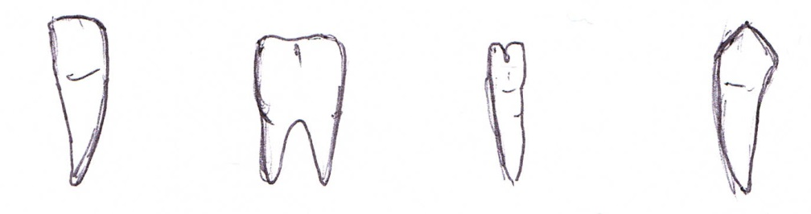

Incisor Molar Pre-Molar Canine

£1.25 £1.50 £1.00 £2.00

The tooth fairy has left £5 under your pillow.

What combination of teeth could you have left for her?

Record in your books.

C:\Users\Gareth\AppData\Local\Microsoft\Windows\Temporary Internet Files\Content.IE5\UVKSZWHB\MC900104178[1].wmf

The Tooth Fairy



Incisor Molar Pre-Molar Canine

25p 50p 75p 10p

The tooth fairy has left £1 under your pillow.

What combination of teeth could you have left for her?

Record in your books.

C:\Users\Gareth\AppData\Local\Microsoft\Windows\Temporary Internet Files\Content.IE5\UVKSZWHB\MC900104178[1].wmf

The Tooth Fairy



Incisor Molar Pre-Molar Canine

10p 5p 20p 2p

The tooth fairy has left 50p under your pillow.

What combination of teeth could you have left for her?

Record in your books.

C:\Users\Gareth\AppData\Local\Microsoft\Windows\Temporary Internet Files\Content.IE5\UVKSZWHB\MC900104178[1].wmf

The Tooth Fairy



Incisor Molar Pre-Molar Canine

10p 5p 2p 1p

The tooth fairy has left 20p under your pillow.

What combination of teeth could you have left for her?

Record in your books.

C:\Users\Gareth\AppData\Local\Microsoft\Windows\Temporary Internet Files\Content.IE5\UVKSZWHB\MC900104178[1].wmf

The Tooth Fairy

 

Incisor Molar Canine

1p 2p 5p

The tooth fairy has left 10p under your pillow.

What combination of teeth could you have left for her?

Record in your books.