1. Sam and his sister watched a cartoon at 8 o’clock for 1 hour.

What time did the cartoon finish? ____ o’clock.

2. We went to the seaside. We set off at 11 o’clock, the journey took us 1 hour.

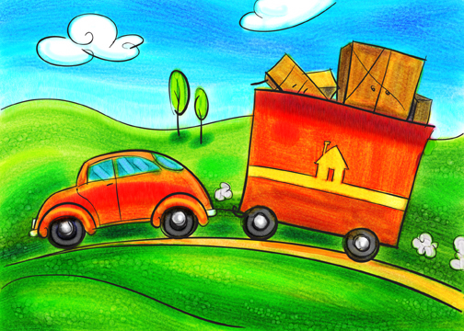

What time did we get to the
seaside? ___ o’clock.

3. Our class did P.E outside. We went out at 2 o’clock for 1 hour.

What time did P.E finish? _____ o’clock.

4. We made a cake and put it in the oven at 5 o’clock for 1 hour.

What time was the cake ready? ____ o’clock.

5. My friend came around to play at half past 3. He stayed for 1 hour.

What time did he go home? ___ o’clock.

6. Me, mum and dad went swimming at 10 o’clock for 1 hour.

What time did finish swimming? _____ o’clock.

7. Mum took me shopping for my school uniform. We left at 2 o’clock and were out for half an hour.

What time did we get back? ____ o’clock.

8. I had a bath at 7 o’clock, I was in there for half an hour.

What time did I get out? _____ o’clock.

9. We had pizza for dinner. It went in the oven at half past 5 and took 30 minutes to cook.

What time was the pizza ready? _____ o’clock.

