Name …………………………………………………………………
Time Problems
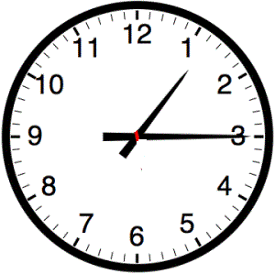
- Kerry catches the bus as 1:15. Her journey takes her 20 minutes. What time does she arrive?

- Kate is going to her Aunt’s house. It takes her 25 minutes to get there in the car. She leaves at 2:05. What time will she arrive at her Aunt’s house?

- Jack watches a movie on the TV. It starts at 3:30 and lasts for 50 minutes. What times does it finish?

- Matthew has been very busy at the sports centre. He started playing tennis at 10:00 and played for 45 minutes. Then he played basketball for 20 minutes. What time is it now?

- Joseph has been playing on the Xbox for 50 minutes. His mum tells him it is now 9:10. What time did he start to play?

