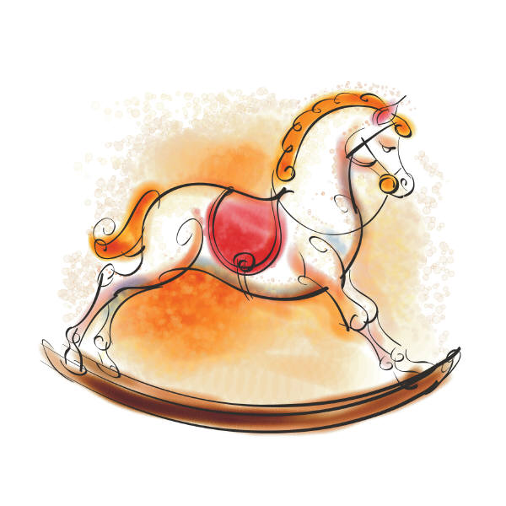
Tina’s Toy Shop problems - 1

- Tina has to sell bouncy balls in bags. Each bag holds 4 balls. How many balls will she need for 8 bags?

- Each ball costs 6p, how much money will Peter need to buy 4 balls?

- Sarah comes to the shop to buy a teddy bear. She has £3.00. The teddy that she wants to buy is too much money. It costs £12.00. How much more money will she need to save up?

- If Sarah gets £3.00 every Saturday. How many weeks will it take for her to have enough money for the teddy?

- Tina decides to sell dolls house chairs in sets of 4. Each chair costs 10p how much will a set of four cost?

Tina’s Toy Shop problems - 2

- Tina has to sell bouncy balls in bags. Each bag holds 4 balls. How many balls will she need for 16 bags?

- Each ball costs 18p, how much money will Peter need to buy 4 balls?

- Sarah comes to the shop to buy a teddy bear. She has £12.00. The teddy that she wants to buy is too much money. It costs £48.00. How much more money will she need to save up?

- If Sarah gets £4.00 every Saturday. How many weeks will it take for her to have enough money for the teddy?

- Tina decides to sell dolls house chairs in sets of 4. Each chair costs 15p how much will a set of four cost?

Tina’s Toy Shop problems - 3

- Tina has to sell bouncy balls in bags. Each bag holds 4 balls. How many balls will she need for 32 bags?

- Each ball costs 44p, how much money will Peter need to buy 4 balls?

- Sarah comes to the shop to buy a teddy bear. She has £24.00. The teddy that she wants to buy is too much money. It costs £64.00. How much more money will she need to save up?

- If Sarah gets £4.00 every Saturday. How many weeks will it take for her to have enough money for the teddy?

- Tina decides to sell dolls house chairs in sets of 4. Each chair costs 58p how much will a set of four cost?

