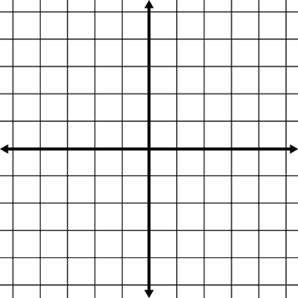
LO To be know how to translate a shape on a grid
Move 5 units left, 3 units down
Move 6 units right, 5 units down
Move 2 units left, 8 units down
Move 6 units right, 5 units up
Draw the shape in the new position after translation
LO To be know how to translate a shape on a grid
Move 5 units left, 3 units down
Move 6 units right, 5 units down
Move 2 units left, 8 units down
Move 6 units right, 5 units up
Draw the shape in the new position after translation and give the coordinates of the new shape.

