**Translation**

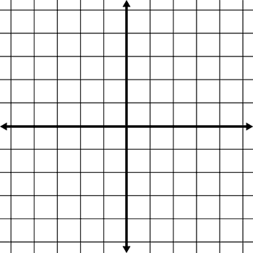

**Move 5 units left and 3 units down**

**Move 6 units right and 5 units down**



**Move 2 units left and 8 units down**

**Move 6 units right and 5 units up**

**A**

**B**

**C**

**D**

**A**

**B**

**C**

**A**

**B**

**C**

**D**

**A**

**B**

**C**

L.O: To be able to draw the position of a shape after translation.



**Move 7 units left and 3 units down**

**Move 7 units right and 5 units up**



**Move 4 units right and 3 units down**

**Move 8 units left and 5 units up**

**A**

**B**

**C**

**D**

**A**

**B**

**C**

**A**

**B**

**C**

**D**

**A**

**B**

**C**