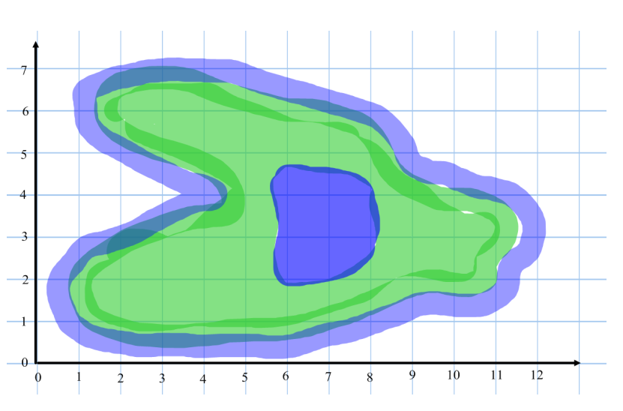
Name: _________________ Treasure Island
The island has many palm trees growing on it. Put a ‘P’ for each palm tree at the following coordinates:
(4,2) (10,3) (3,6) (7,5)
There is a patch of quick sand on the island, Put a ‘Q’ at location (2,6)

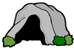
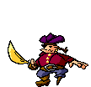



Sharks patrol around the island in the sea. Put an ‘S’ at the following points: (11,6) (12,1) (1,4)
Write the coordinate of the following objects:
( , )
( , )
( , )
( , )
( , )

