Name ____________________________________________ Date _______________

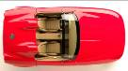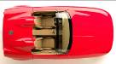

¼ turn ½ turn A full turn

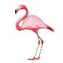


 | ¼ | 1 | ½

 | ½ | ¼ | 1
LO I can make whole turns, half turns and quarter turns

