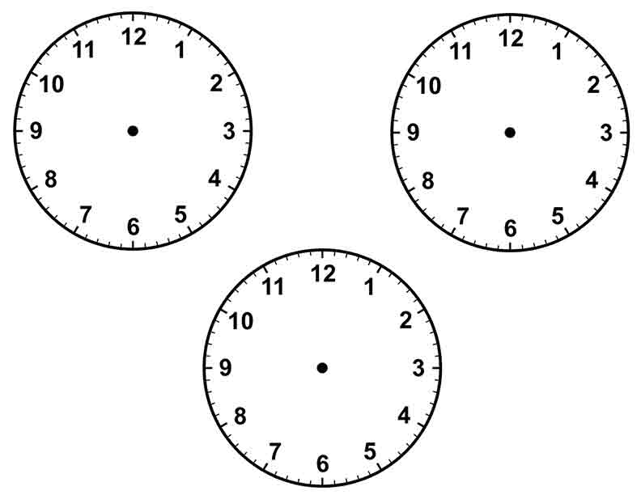  3 | o’clock
5 | o’clock
2 | o’clock
4 | o’clock
10 | o’clock
8 | o’clock
11 | o’clock
7 | o’clock

