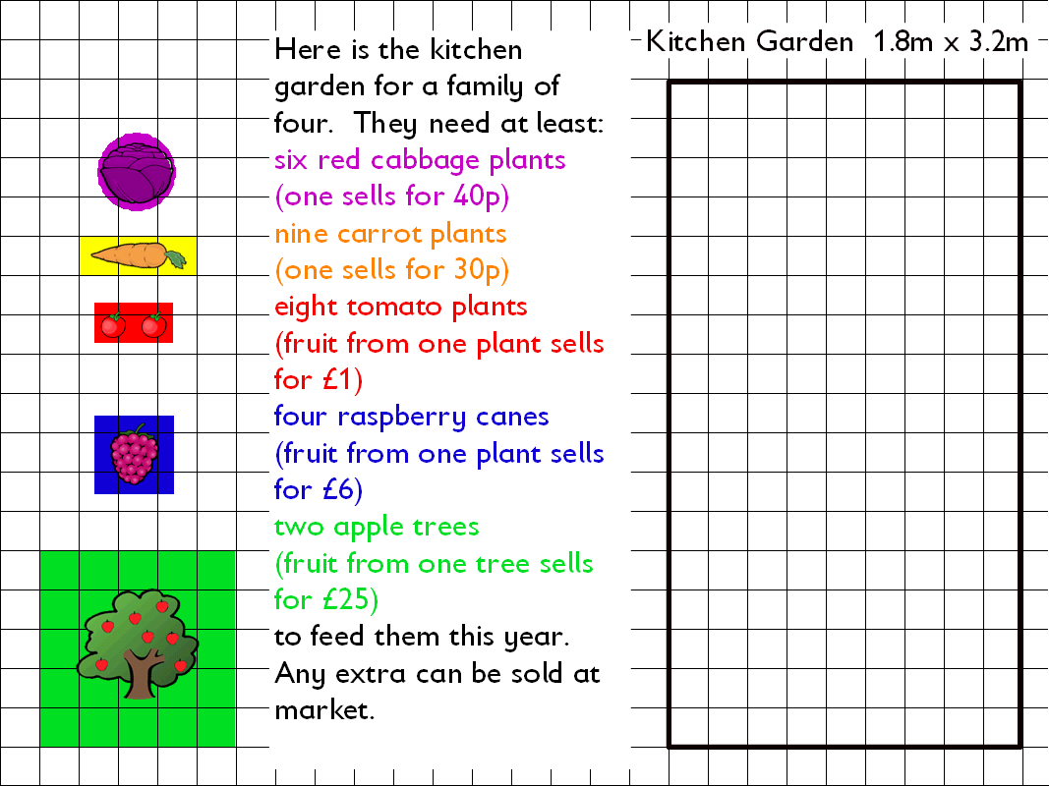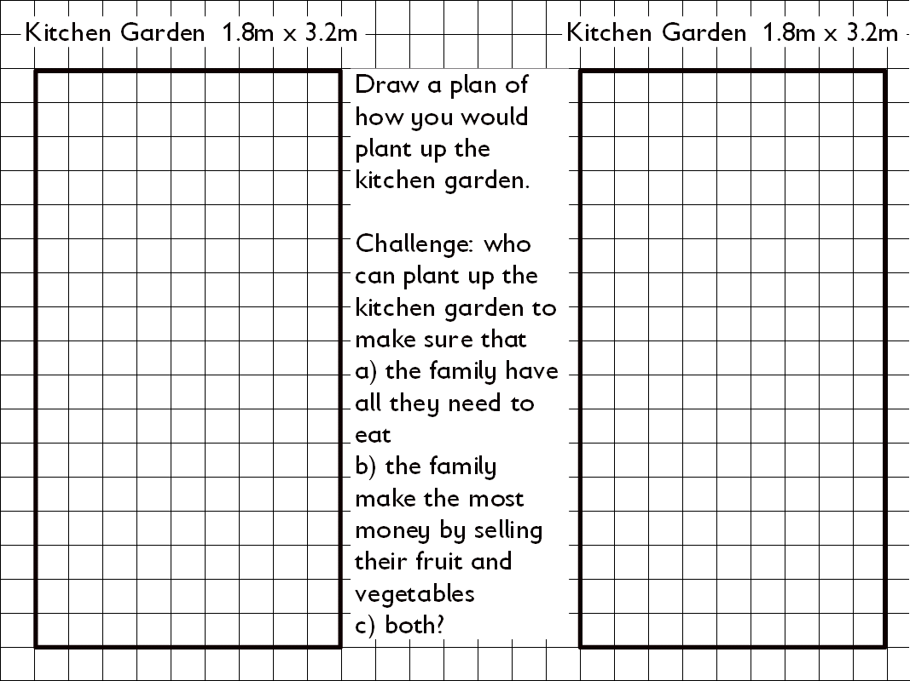
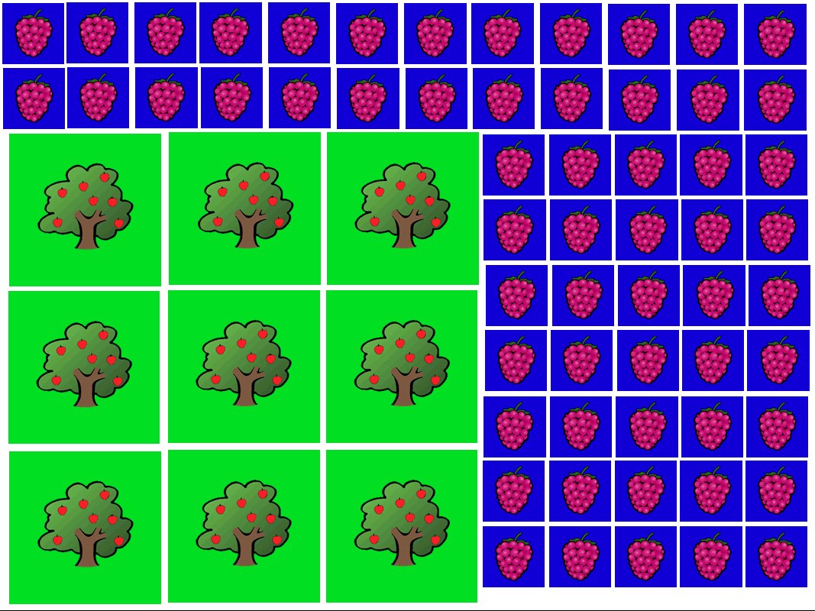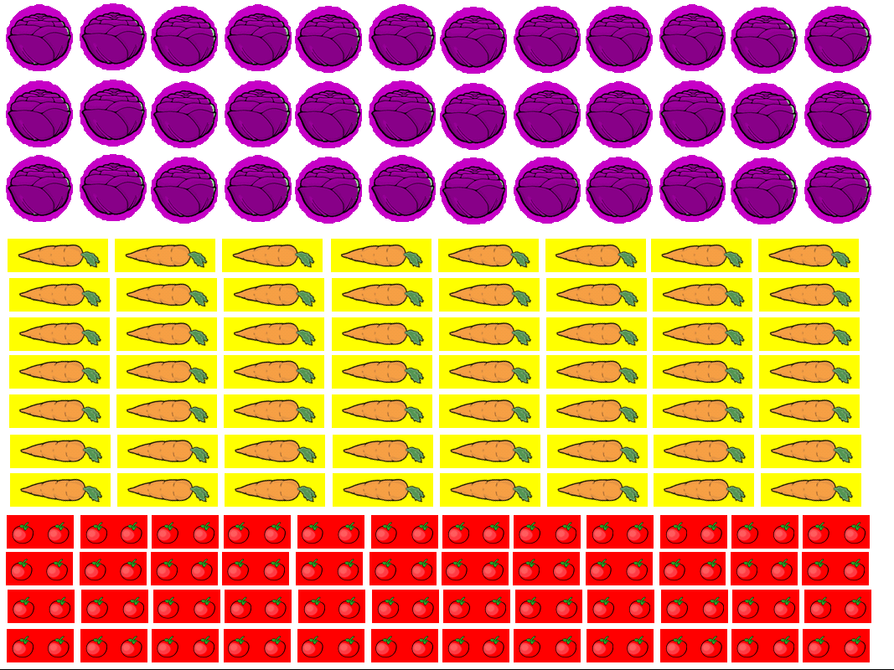

These worksheets can be used in conjunction with the flipchart for use with Promethean software. Some objects in the flipchart are locked on the background. Right click in design mode to unlock objects.

