Name:_____________________ Date:______________________

What can you do in a minute?

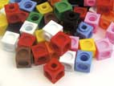  Can you build a tower of 30 cubes? | 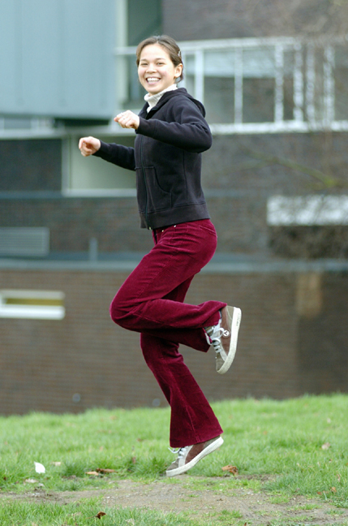  How many hops can you do?
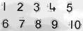  Which number can you write up to? | How many times can you click your fingers?  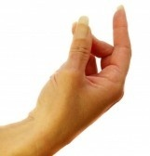
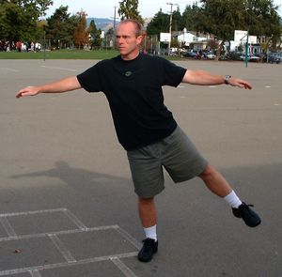  Can you stand on one leg for a minute without falling? | How many times can you write your name?  