What is the Time?

January March December April
February May November July
When is your birthday? June August October September

What month is it now? _______________________

What day is it today? Monday Tuesday Wednesday Thursday
Friday Saturday Sunday

What time do you get up in the morning? ____________________
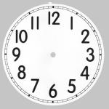
What time do we have dinner in school? _____________________
What time is it when you go home? ______________________
What time is it when you go to bed? _______________________

