Name:____________________ Date:____________________

What Time is it?
Can you put the Big Hand and the Little Hand in the right place on these clocks?

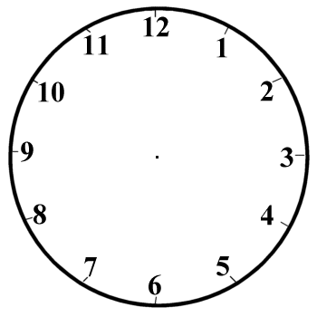
o’clock o’clock o’clock

o’clock o’clock o’clock

o’clock o’clock o’clock

o’clock o’clock o’clock

o’clock o’clock o’clock

o’clock o’clock o’clock

o’clock o’clock o’clock

