BOGOF! ☺

Which is the best deal?

 | price | offer | I want
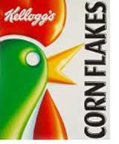 | £1.50 | 2 for £2.50 | 2 boxes
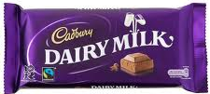 | 80p | 5 for £3.50 | 5 bars
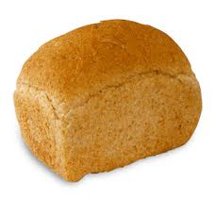 | £1.10 | 3 for £3.50 | 3 loaves
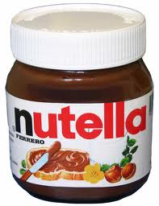 | £2.30 | 3 for £6.50 | 3 jars
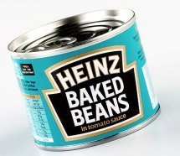 | 52p | 4 pack for £2.10 | 4 tins
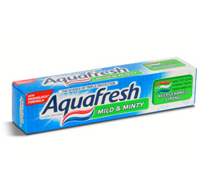 | £2.75 | 3 for £ 7.50 | 3 tubes
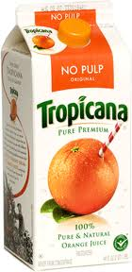 | £2.28 | 3 for £6 | 6 cartons
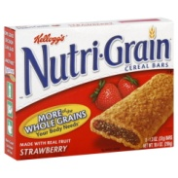 | £2 for 6 | £3.29 for 12 | 12 bars
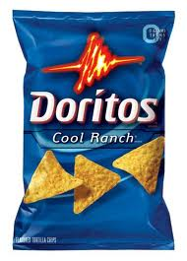 | 60p per bag | £5.49 pack of 12 | 10 bags
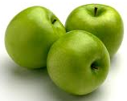 | £1.60  per kg  (5 apples) | bag of 10 apples for £3.50 | 20 apples

