Name: …………………………………………………. Date: …………………..

World Time and 24 hour clock - Part 1

1. The time in London is 15:00. What time is it in…

Bhagdad …………………………………..

Dhaka …………………………………..

Tokyo …………………………………..

Utah …………………………………..

Hawaii …………………………………..

Somoa …………………………………..

Islamabad …………………………………..

Alaska …………………………………..

2. Fill in the following:

Muscat time: 11:00 ………….London time: …………………….

Seoul time: 14:00…………….London time: …………………….

San Fran time: 13:00…………London time: …………………….

Bermuda time: 10:00…………London time: …………………….

Costa Rica time: 15:00…………London time: …………………….

Maldives time: 10:00…………London time: …………………….

Alaska time: 08:00…………London time: …………………….

3. The time in Istanbul is 19:00. What time is it in…

London …………………………………..

South Georgia …………………………………..

Tokyo …………………………………..
Name: …………………………………………………. Date: …………………..

World Time and 24 hour clock - Part 2

1. The time in Utah is 21:00 on Christmas Day. What is the time and date in…

Hawaii …………………………………..

London …………………………………..

Tokyo …………………………………..

Baghdad …………………………………..

2. The time in Bermuda is 04:00 on Christmas Day. What is the time and date in…

Alaska …………………………………..

London …………………………………..

Bangkok…………………………………..

Tokyo …………………………………..

3. The time in Moscow is 16:00 on June 1. What is the time and date in…

Hawaii …………………………………..

Brisbane …………………………………..

Tokyo …………………………………..

Costa Rica …………………………………..

4. A plane leaves London at 16:00. It arrives 4 hours later in Istanbul. What is the time in Istanbul when the plane lands?

Istanbul …………………………………..

Name: …………………………………………………. Date: …………………..

World Time and 24 hour clock - Part 3

1. A plane leaves London at 16:00. It arrives 8 hours later in Lima. What is the time in Lima when the plane lands?

Lima …………………………………..

2. A plane leaves New York at 09:15. It arrives 5 hrs. 45 min later in London. What is the time when the plane lands in…

London: ……………………

3. A plane leaves Athens at 22:00 on Christmas Eve and travels for 8 hours before arriving in Jakarta. What is the time and date when the plane lands in…

Jakarta: …………(time)…………………………..(date)

4. A plane leaves London at 22:00 on May 8. It arrives 8 hours later in Dhaka before continuing for another 4 hours to Tokyo. What is the time and date when the plane lands in…

Dhaka …………(time)…………………………..(date)

Tokyo …………(time)…………………………..(date)

5. A plane leaves Beijing at 12:30 on May 8. It arrives 8.30 hours later in South Georgia before continuing for another 4:30 to Costa Rica. What is the time and date when the plane lands in…

South Georgia …………(time)…………………………..(date)

Costa Rica …………(time)…………………………..(date)
Recap sheet – World time

Name:_________________________________ Date: ________________

Please complete the times in the following cities

London  08:00 | Amsterdam | Baghdad | Beijing | Tokyo
Costa  Rica | Panama | Rio | South Georgia | London  13:00
Alaska | Rio | London  12:00 | Moscow | Seoul
Panama  08:00 | Bermuda | London | Moscow | Seoul
Hawaii  06:00 | San Fran | Amsterdam | Abu Dhabi | Bangkok
Somoa | South Georgia | Amsterdam  12:00 | Abu Dhabi | Solomon Islands
Lima | Buenos Aires | Berlin  14:00 | Islamabad | Auckland
Alaska | Athens  09:00 | Baghdad | Jakarta | Singapore
Calgary | Buenos Aires | Baghdad  12:00 | Muscat | Brisbane
Honduras | South Georgia | Istanbul  12:00 | Maldives | Figi
Berlin | Istanbul | Maldives | Seoul  18:00 | Auckland

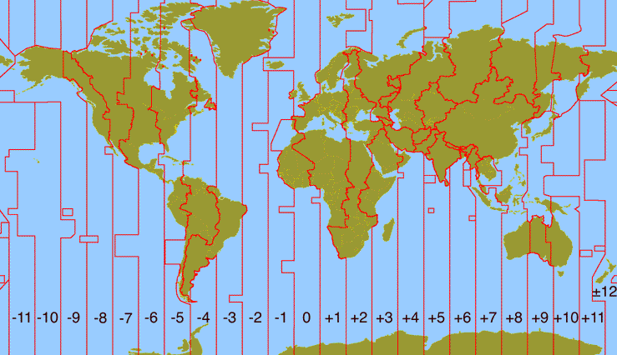
Somoa | Hawaii | Alaska | San Fran; Mexicali | Utah; Calgary | Costa Rica; Honduras | Panama; Lima | Bermuda; Falklands | Rio; Buenos Aires | South Georgia | Praia, Cape Verde | London; Lisbon | Amsterdam, Berlin | Athens, Istanbul | Baghdad, Moscow | Abu Dhabi; Muscat | Islamabad; Maldives | Dhaka; Kazakhstan | Bangkok; Jakarta | Beijing; Singapore | Tokyo; Seoul | Brisbane; Sydney | Solomon Islands | Auckland; Figi

