Using written methods for multiplication
We have learnt the grid method and column method for multiplication.
For example:
56 x 9
- GRID METHOD
I start by splitting the two-digit number into Tens and Units:
56 = 50 + 6
Then I put this into a special grid:
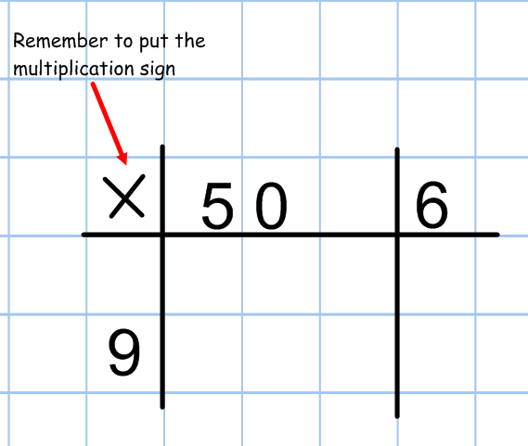
Now I multiply 9 by the tens and the units separately:
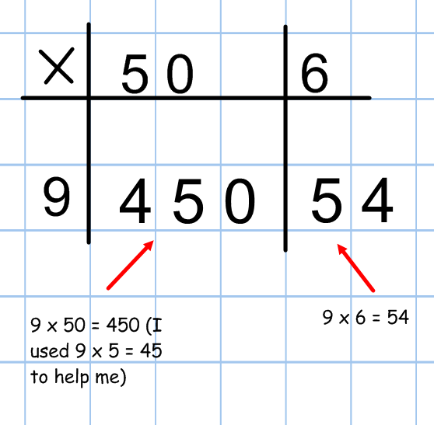
Then I add the two parts together: 450 + 54 = 504. That’s my answer!
You can also do this for a two-digit number multiplied by another two-digit number.
e.g. 32 x 25
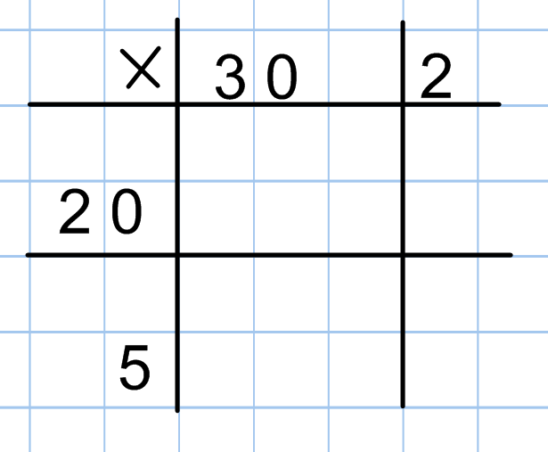
I start in the same way, except this time I partition BOTH the numbers into tens and units.

Now I multiply out each column and row
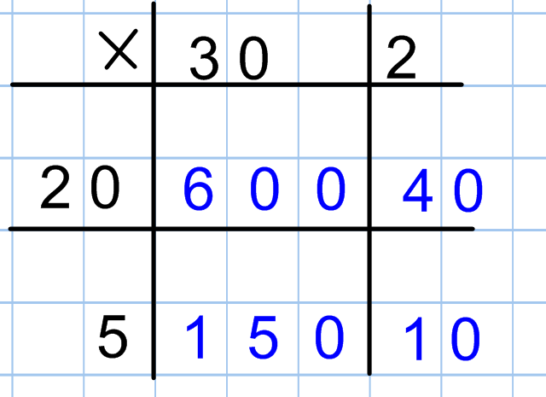
Finally I add up all the blue numbers (the answers to the multiplications):
600 + 150 + 40 + 10 = 800

- COLUMN METHOD
This method also involves partitioning. I start by writing out the multiplication in columns:
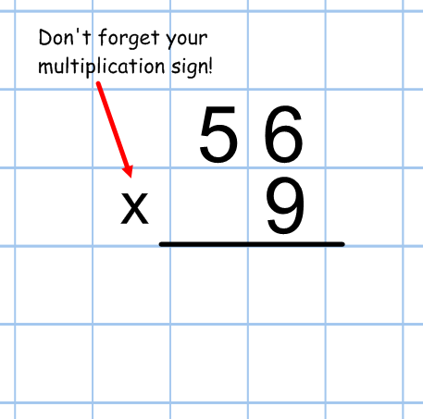
Next I partition the two-digit number and multiply each part by 9
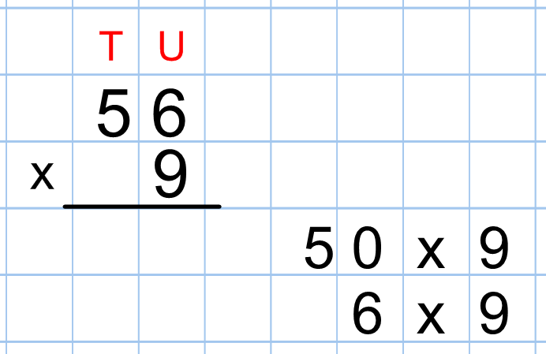
Now I work out the answer for each part and write it under the Tens and Units columns
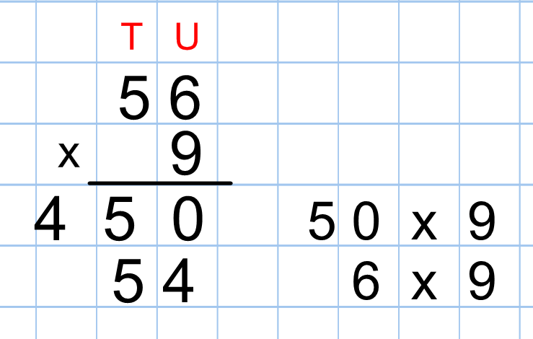
Finally, I add the partitioned answer back together:
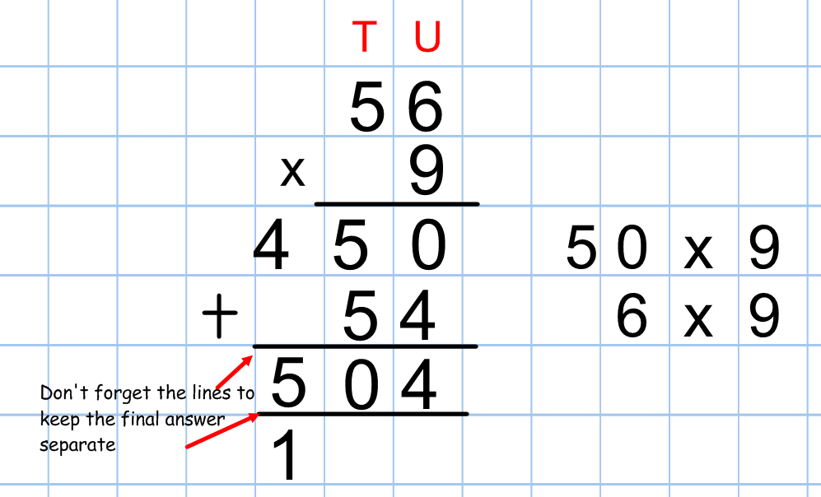
Using a written method for division
We have learnt one written division method, which is division by chunking.
e.g. 153 ÷ 9
Start by writing the division like this:
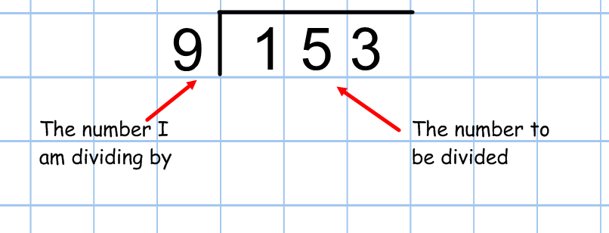
With this method I then have to ask myself the question: “How many groups of 9 can I fit into 153?”
I would start by thinking, “Well, I can definitely fit at least 10 groups of 9 into 153 because 10 groups of 9 makes 90, and that is less than 153.”
I would record my thoughts in this way:
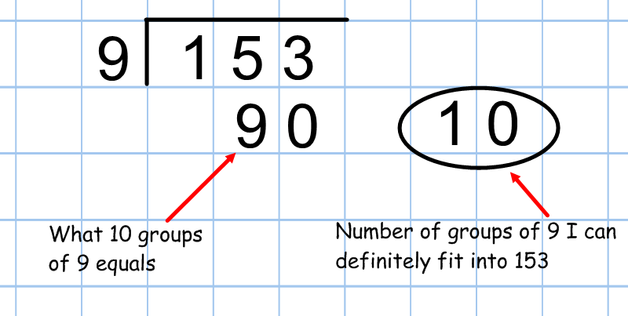
I now need to work out how much I have left, when I have taken away those ten groups of 9, so I subtract 90 from 153:
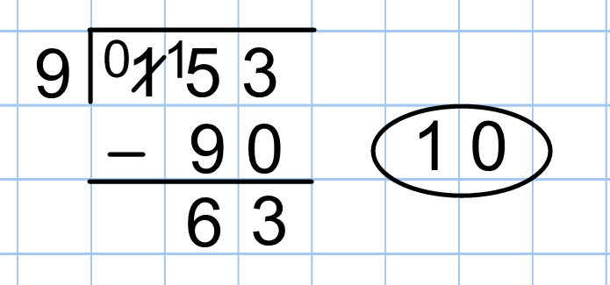
I have 63 left. So now I need to ask myself how many groups of 9 I can fit into 63? Luckily, I’m good at my 9 times table and I know that 7 x 9 is 63. I can fit 7 groups of 9 into 63:
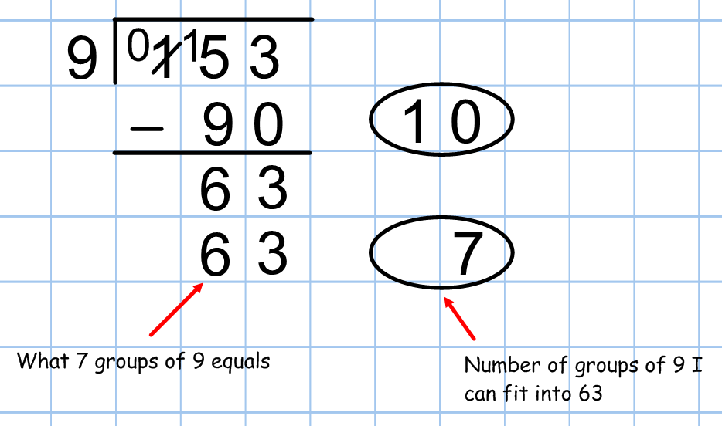
If I then subtract the 7 groups of 9 from 63, I have nothing left, which means I have calculated how many groups of 9 fit into 153. All I need to do is look at the numbers on the right.
