Name: ____________________________________________ Date: ___________________________________

Money Problem Solving
John and Jack go to the shop. John buys a comic for 6p and Jack buys a lollipop for 3p. How much do they spend altogether?   | Mary goes to the shop to buy some fruit. She buys an apple for 5p and an orange for 3p. What is the total amount she paid for the fruit?  
At the fair Sally buys an ice cream for 2p and a cake for 5p. How much does Sally spend at the fair? | Max gives his sister and his brother 5p each. How much money did he give his brother and sister altogether?  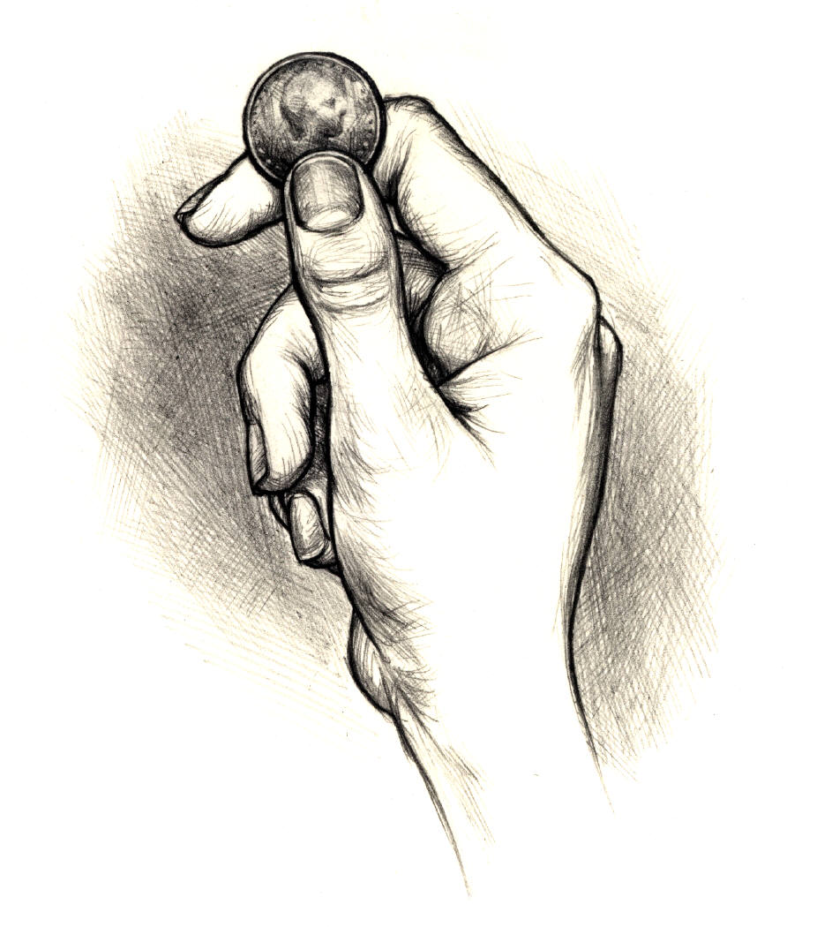
Jo went to the shop and bought some grapes that cost 7p and a cookie that cost 4p. How much money did Jo spend?   | At the shop Jane spent 6p on some flowers and 7p on some chocolates for mum. How much did Jane spend at the shop?  
Name: ____________________________________________ Date: ___________________________________

Money Problem Solving
John and Jack go to the shop. John buys a comic for 17p and Jack buys a lollipop for 15p. How much do they spend altogether?   | Mary goes to the shop to buy some fruit. She buys an apple for 12p and an orange for 14p. What is the total amount she paid for the fruit?
At the fair Sally buys an ice cream for 19p and a cake for 11p. How much does Sally spend at the fair? | Max gives his sister and his brother 10p each. How much money did he give his brother and sister altogether?
Jo went to the shop and bought some grapes that cost 18p and a cookie that cost 8p. How much money did Jo spend? | At the shop Jane spent 17p on some flowers and 10p on some chocolates for mum. How much did Jane spend at the shop?
Name: ____________________________________________ Date: ___________________________________

Money Problem Solving
Challenge! Solve these problems and work out how much change you would get from 50p.
John and Jack go to the shop. John buys a comic for 17p and Jack buys a lollipop for 15p. How much do they spend altogether? | Mary goes to the shop to buy some fruit. She buys an apple for 12p and an orange for 14p. What is the total amount she paid for the fruit?
At the fair Sally buys an ice cream for 19p and a cake for 11p. How much does Sally spend at the fair? | Max gives his sister and his brother 10p each. How much money did he give his brother and sister altogether?
Jo went to the shop and bought some grapes that cost 18p and a cookie that cost 8p. How much money did Jo spend? | At the shop Jane spent 17p on some flowers and 10p on some chocolates for mum. How much did Jane spend at the shop?

