Instructions:

- Fold in half to A5 size to make crease
- Fold in half again to make another crease
- Fold in half again to make a third crease
- Unfold back to A5 size
- Then, with paper in landscape orientation, cut down middle to half way point (see diagram)

- Open back out to A4 size, then fold in half lengthways
- Pull 2 middle sections outwards to make a cross shape

pull
push

push
pull

- Fold pages down to make booklet
La
Nativité

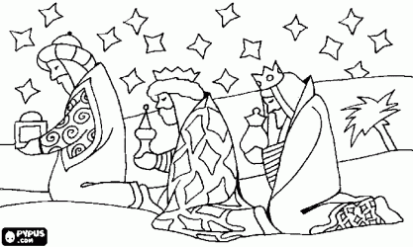
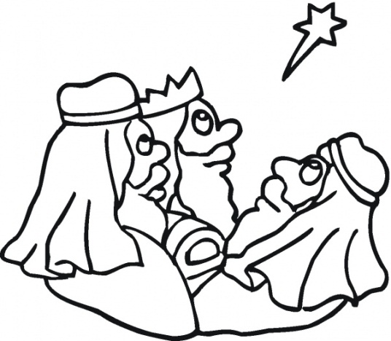
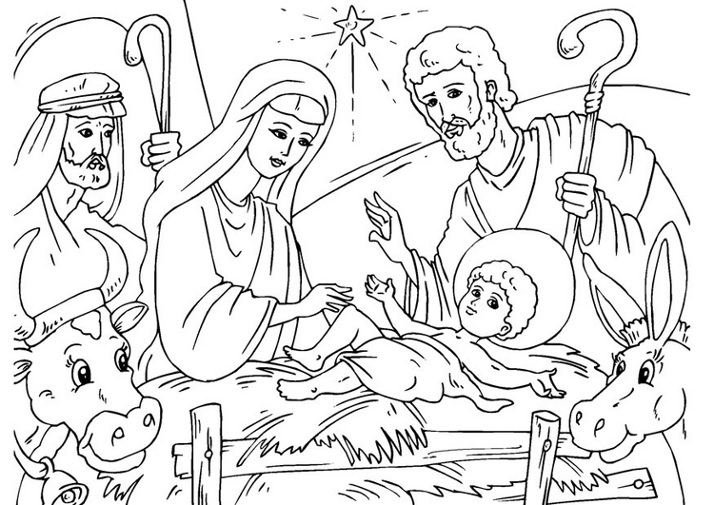
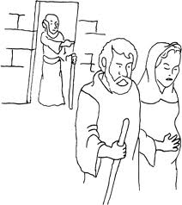
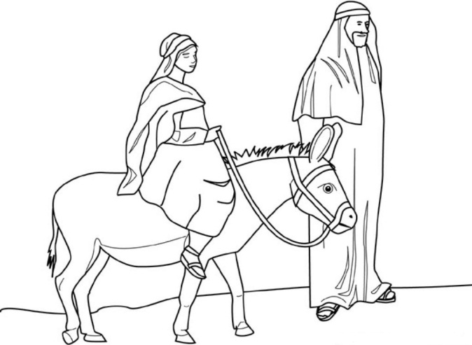
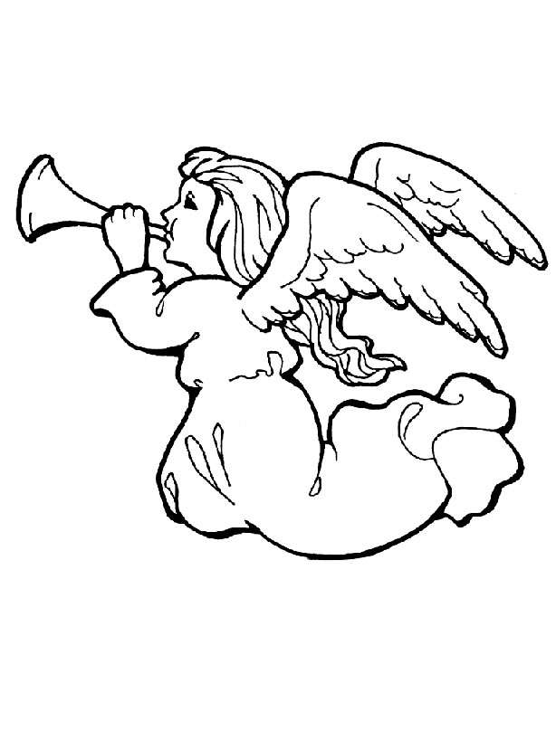
Ils apportèrent de l’or, de l’encens et de la myrrhe.
Les trois rois ont suivi une étoile à Jésus.
Jésus est né dans l’étable.
Il n’y avait pas de place à l’auberge .
Marie et Joseph se rendit à Bethléem sur
un âne.
L’ange dit à Marie qu’elle va avoir un bébé.
La Nativité

