

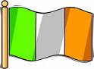

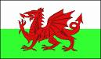



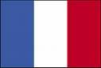

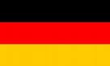

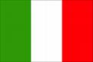

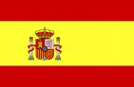

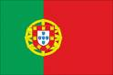

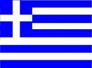

Irlanda

Escocia

Inglaterra

Alemania

Italia

Grecia

Francia

Espana

Portugal

Gales

Los pais = countries
Irlanda ( ear-lon-da ) = Ireland
Gales ( gal-ez ) = Wales
Inglaterra ( ingla- ter- ah ) = England
Escocia ( ess-co-thee-ya ) = Scotland
Alemania ( al-ay-marn-ee-ya ) = Germany
Italia ( ee-tal-ee-ya ) = Italy
Grecia ( greh-thee-ya ) = Greece
Francia ( fran-thee-ya ) = France
Espana ( ess- parn-ee-ya ) = Spain
Portugal ( por-too-gal ) = Portugal

Donde vives ? ( don-day vee-vez ) =
Where do you live ?

Vivo en.. ( vee-voh enn..) = I live in..

