The art of classroom decorating through color

Themes change each term. Therefore, classroom walls can be re-covered with new sheets of colored paper each term.

A colorful classroom not only stimulates participation but also contributes to the retention of information. Colors have an impact on emotions and create feelings of positivity and/or negativity. Creativity, communication, and learning are all influenced by the colors we have around us.

Using a balance of colors creates an environment of happiness and calmness. It is important not to overstimulate learners by using large amounts of bright colors. Big sheets of paper with colors of the Chinese bagua (diagram below) can be used as background throughout the classroom to contribute to balance and harmony.

The teacher writes key aspects of themes on the colored sheets and reviews this material with the class on a regular basis. Theme work and art work produced by the students can also be used to decorate the classroom. Students read information on the walls out loud (shared reading) and participate in game activities to help them remember the material. During music periods, students use popular tunes they all know to sing songs with lyrics they make up from theme material on the walls. These methods contribute to maximum retention of information.

Classroom front door is in blue, black, or gray area.

Creating a love for reading
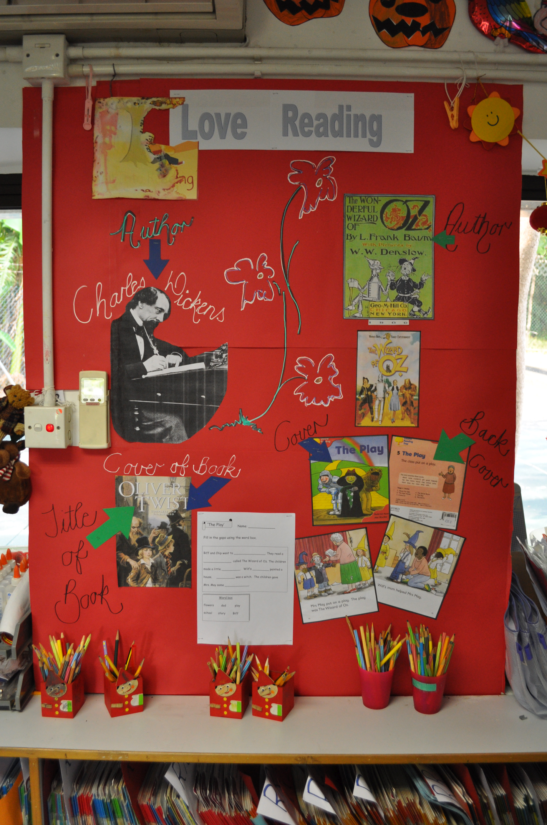

Teaching about South Africa
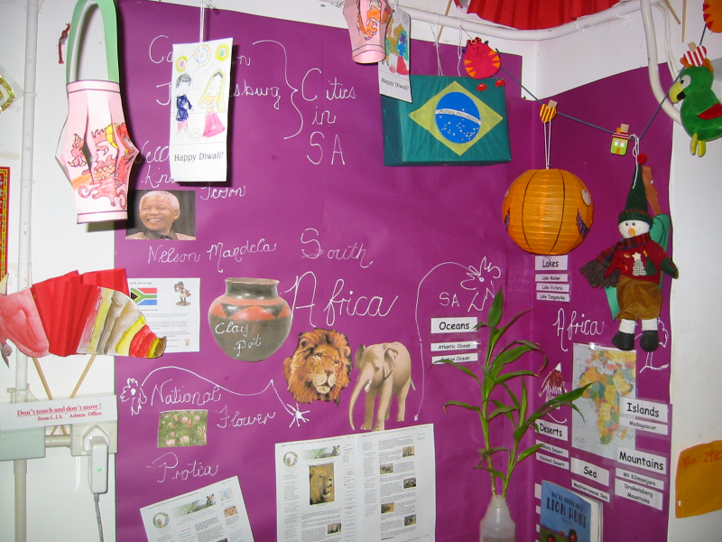

Art Lesson: Sculpture
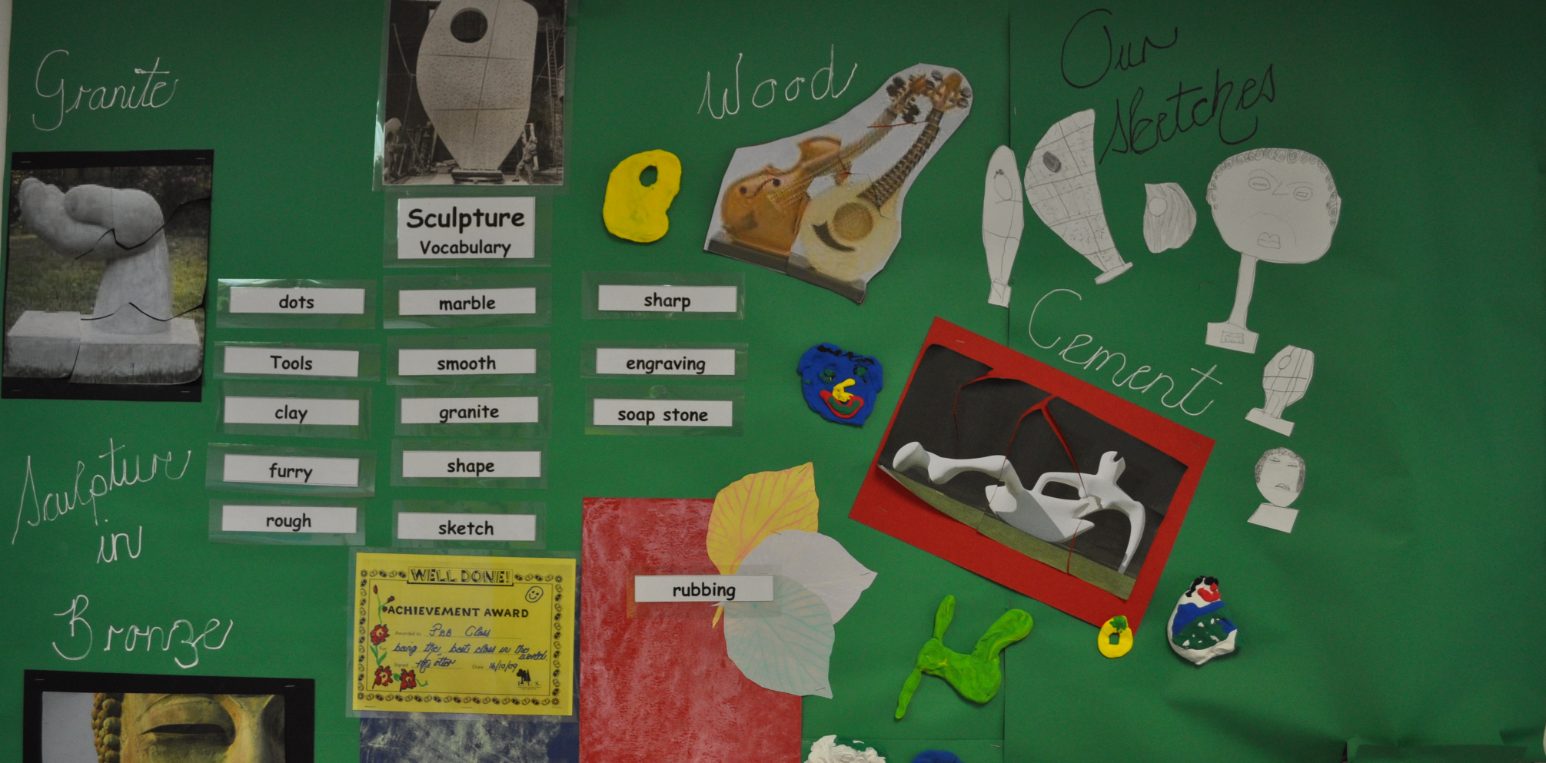

Mind map based on Florence Nightingale Theme
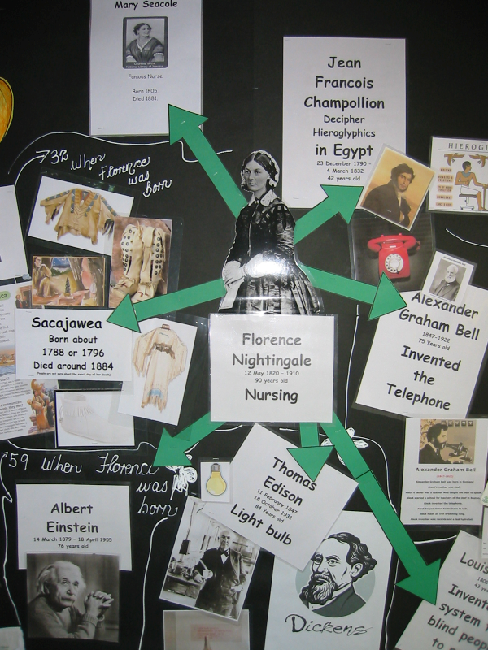

Students filled in a blank copy of this mind map of people whose lives overlapped with Florence Nightingale
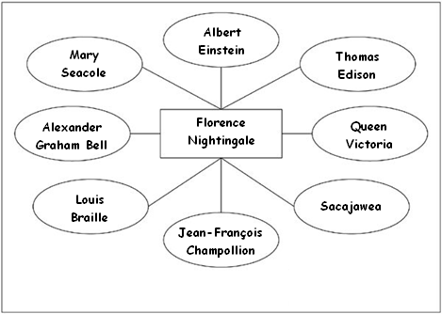

Science, art, and poetry lesson
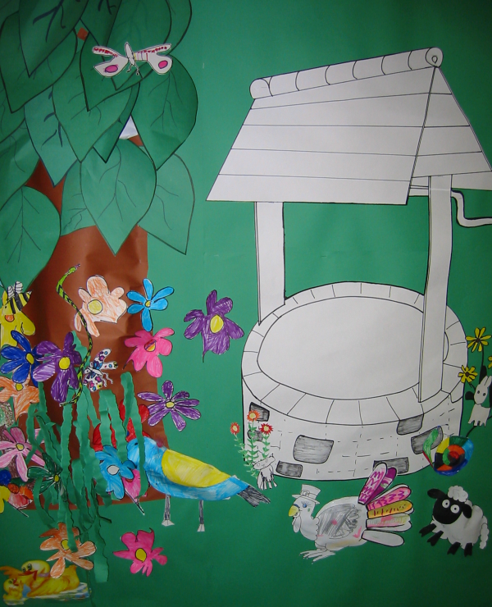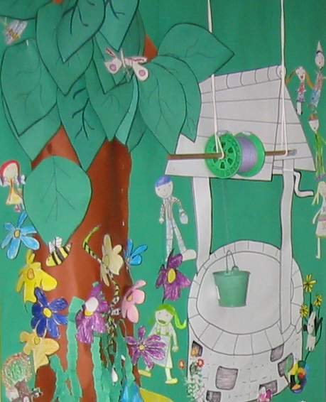
An example of cross-curricular learning: Children’s drawings of local plants and animals were posted around an image of a well (left). After a poetry lesson, students drew Jack and Jill characters, and they were added to the poster (right). Thereafter, the class learned about winding mechanisms and pulleys, and corresponding objects were also added to the poster (right).

A lesson on India
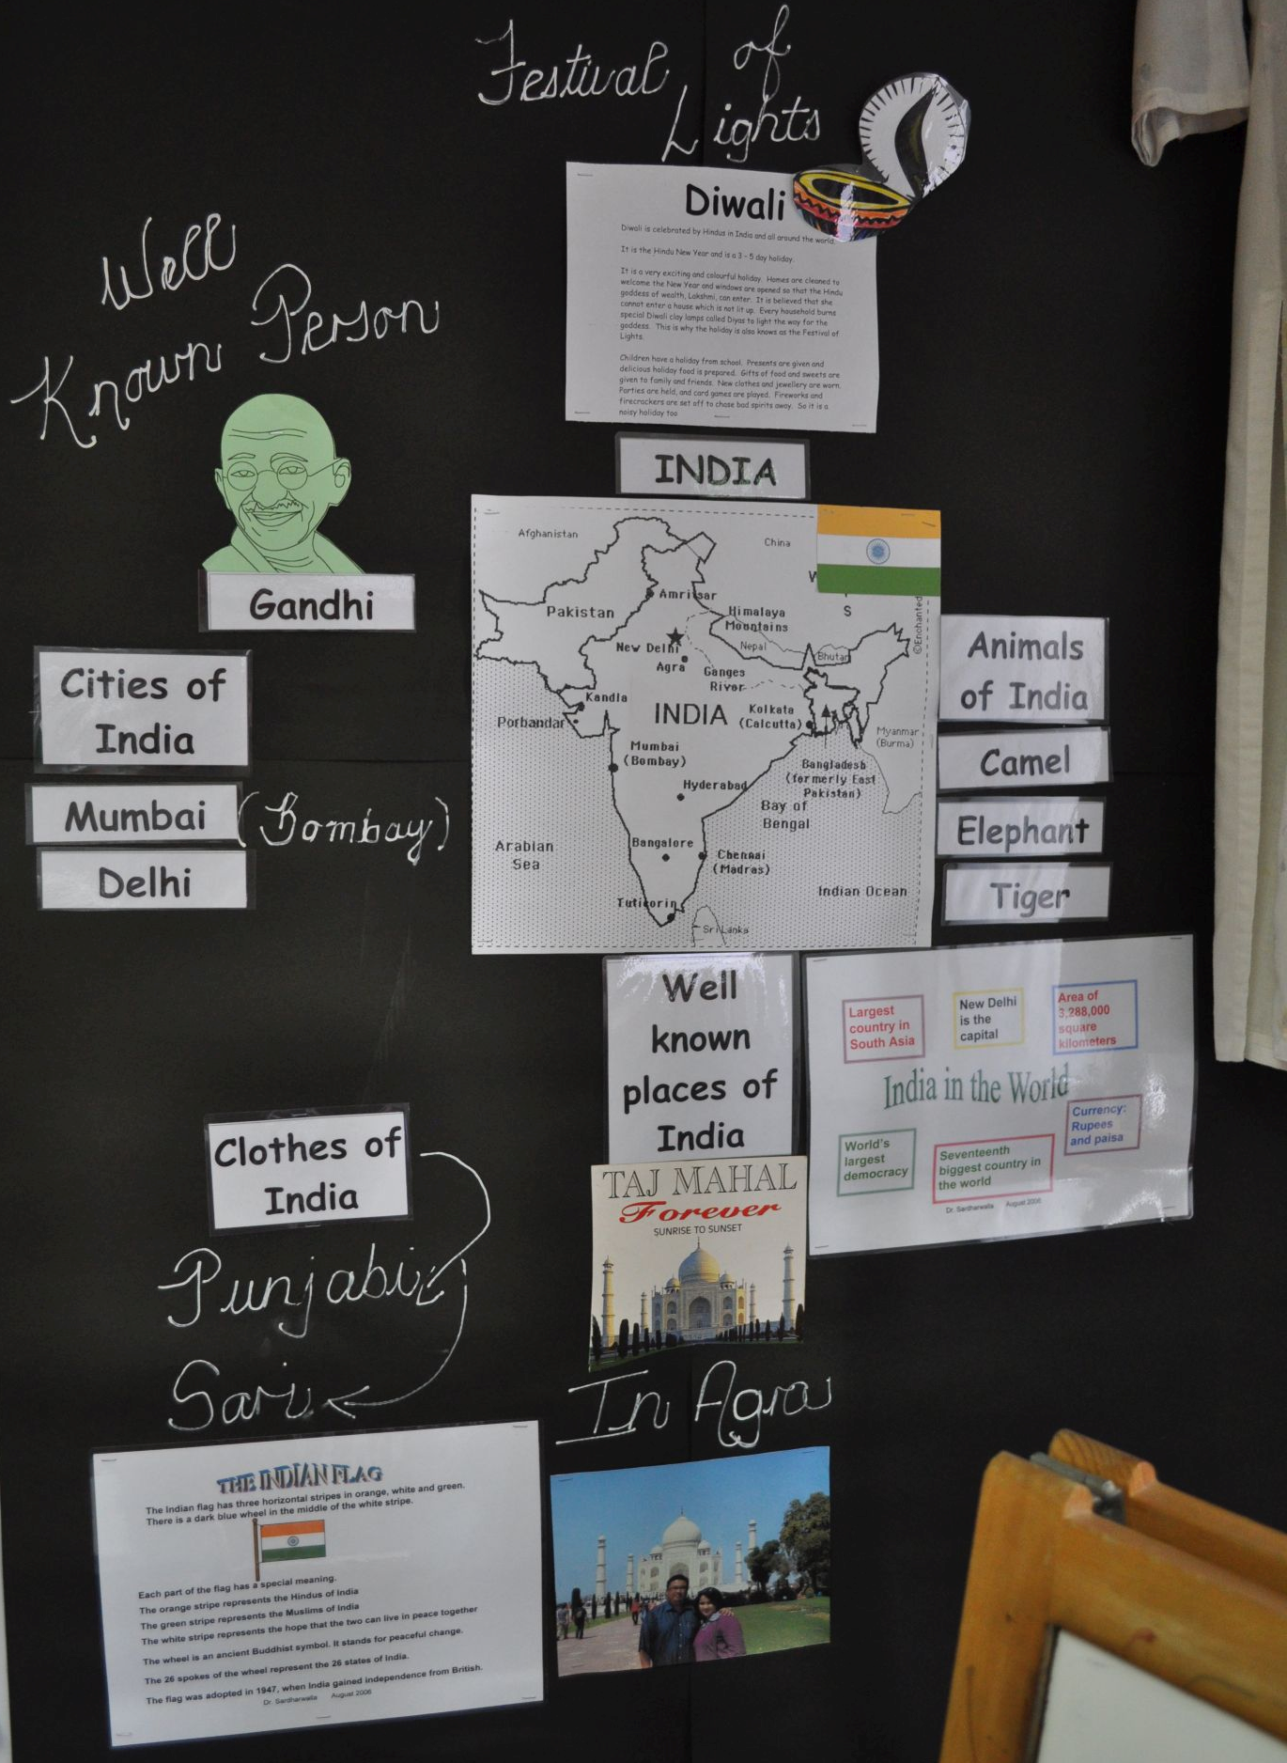

Stimulating lateral thinking
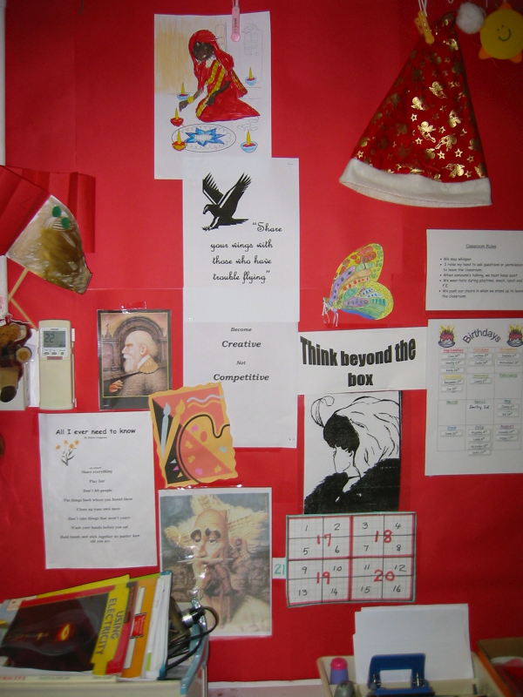

History and art lesson
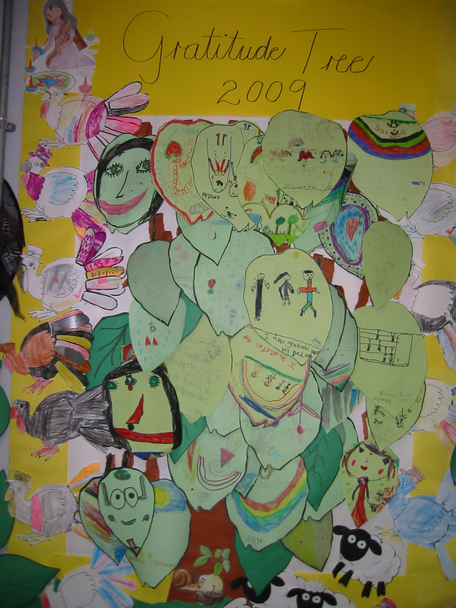
In a Thanksgiving lesson, students wrote gratitude messages on paper leaves and colored animal pictures.

Science lesson and Circle Time
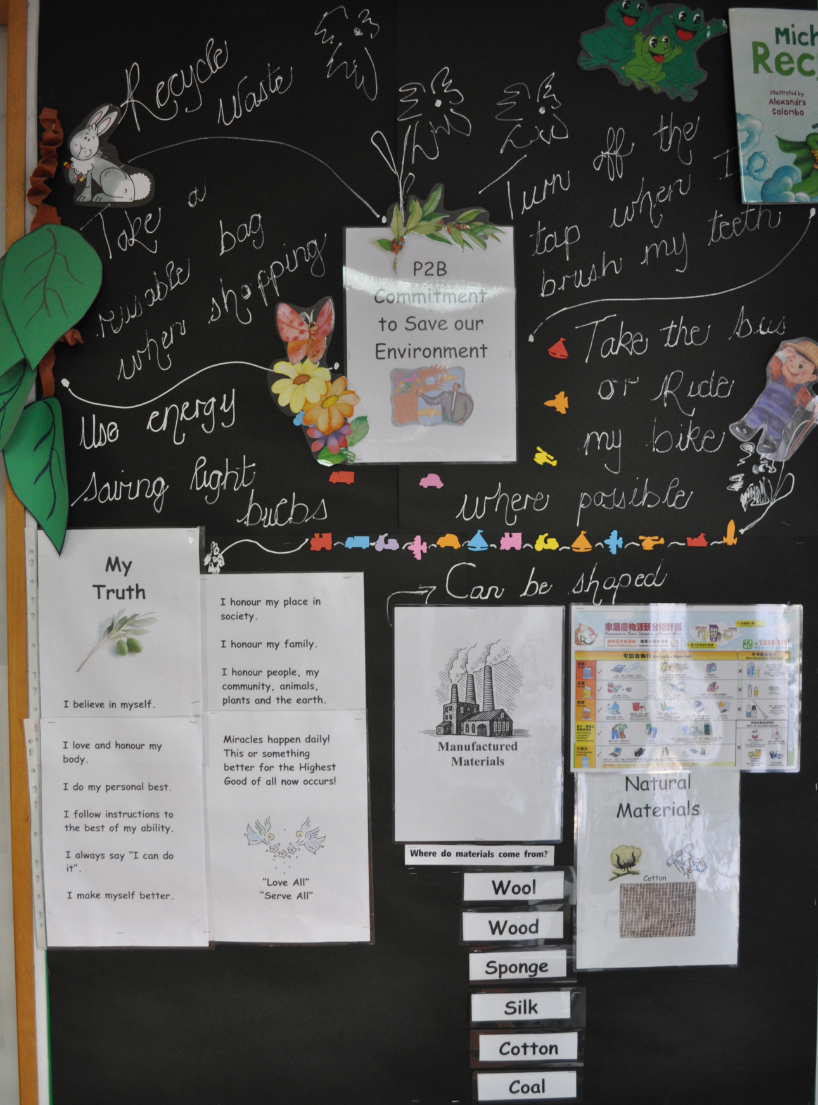

Music lesson
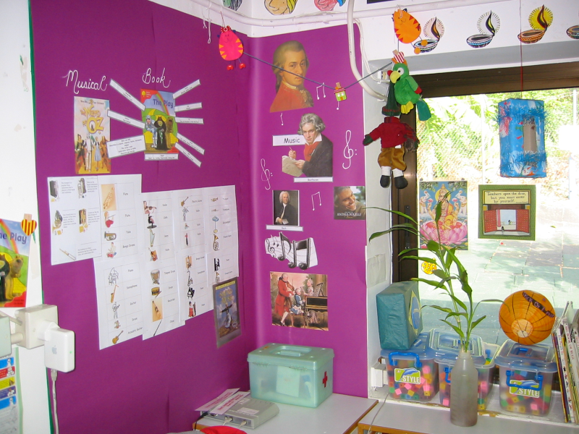

Halloween, Diwali, Christmas, and art lesson
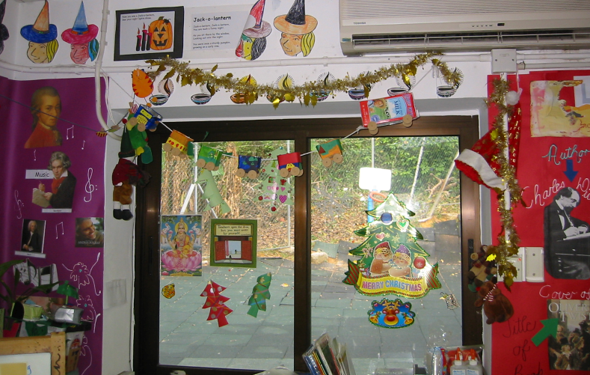

Copyright 2015 by Maria Elizabeth Lotter

