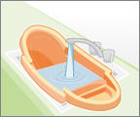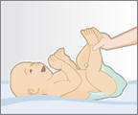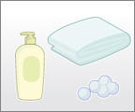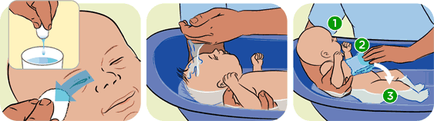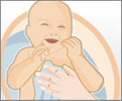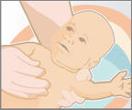

5. Wash the baby’s hair.

4. Clean the baby’s eyes with cotton wool.

3. Put the baby into the bath.

2. Pour water into the baby bath.

7. Wrap the baby in a towel and dry him.

8. Put a clean nappy on the baby.

1. Get everything ready.

6. Wash the baby’s tummy, arms, legs and bottom with a flannel.