WALT: To consider what it means to be me.
Name:

Age:

Birthday:

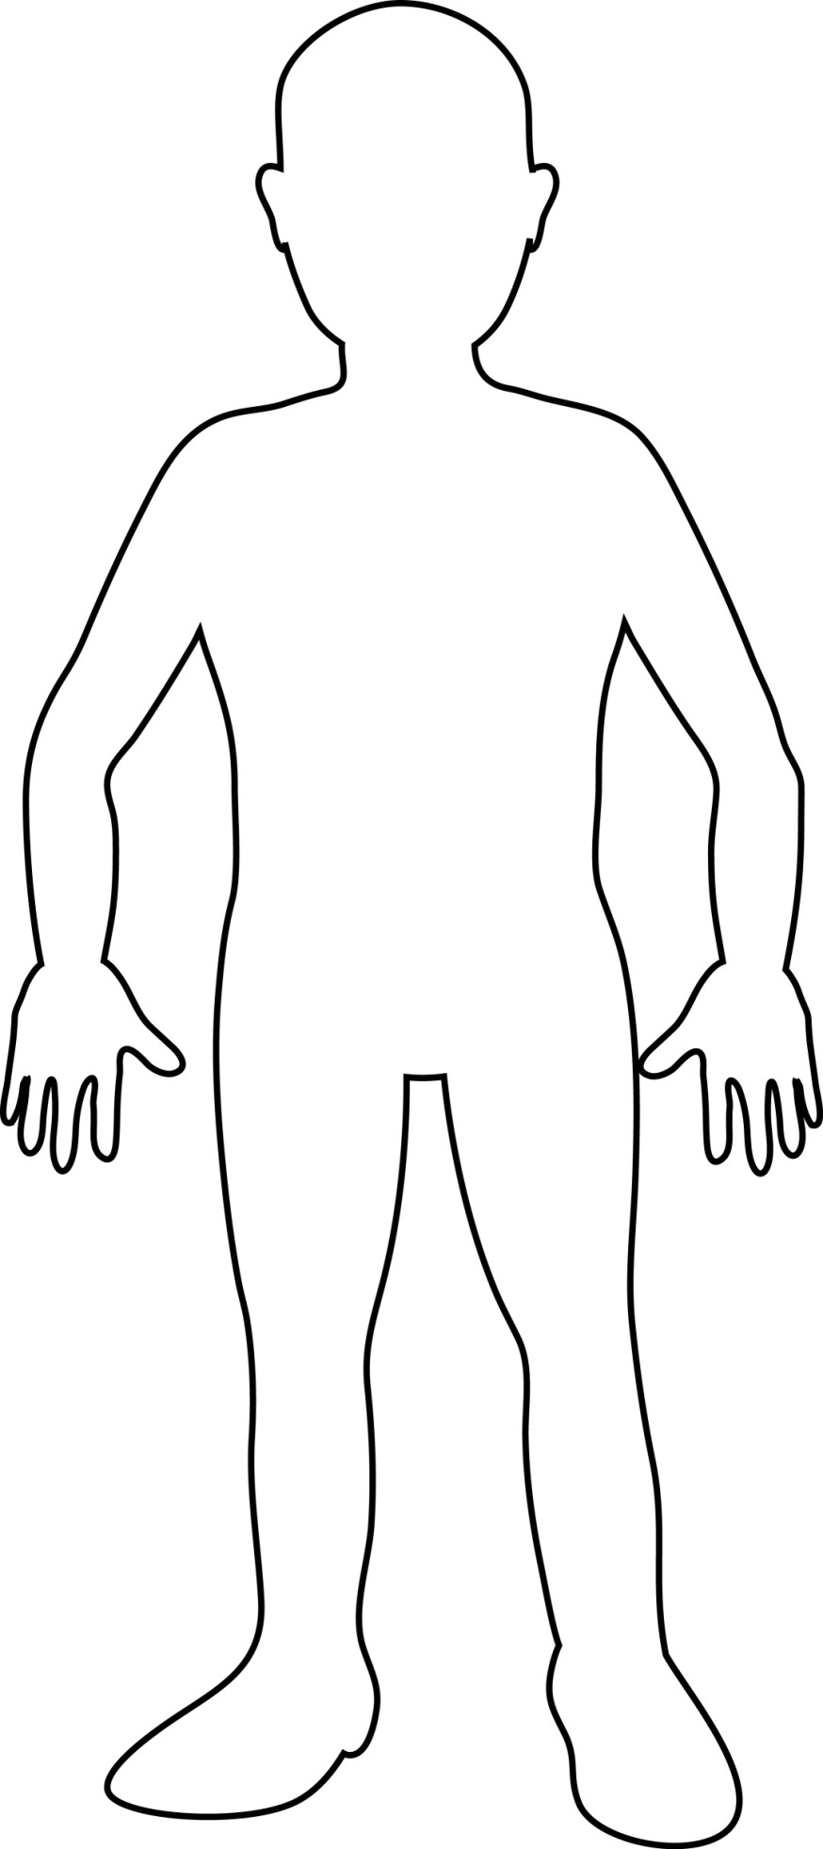

Other interesting things about me:
Things I Like:
Family:

Friends:

