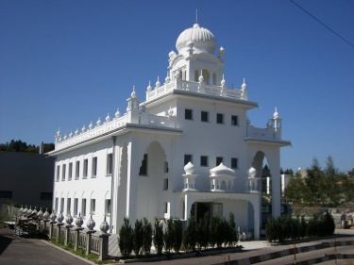

What is a Gurdwara?

What is the Purpose of a Gurdwara?

Why are there no statues or pictures of God in a Gurdwara?

What special object is kept in the Gurdwara?

Where is this special object kept;

During the night

During the day

What is a Guru?

