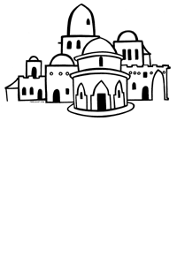
Name …………………………………………..
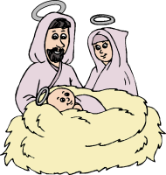




When Jesus Was Born
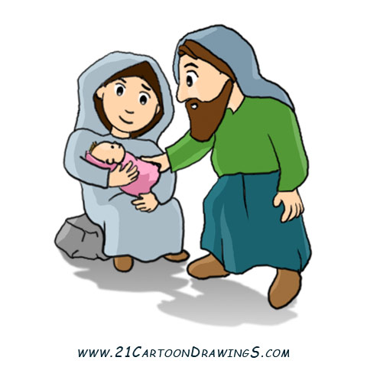
You know the story of the birth of Jesus. We celebrate this every year at Christmas. However, Mary and Joseph had to travel to Bethlehem just before Jesus was born and while they were there Jesus was born in a stable. What things do you know that Mary used to keep baby Jesus warm and comfortable?

Write and draw the things that Mary had in the stable.

Things for a present-day baby
How do present-day families prepare for the birth of a baby? What are the sorts of things that parents-to-be buy for the birth of a baby?
What activities can I do?
Make a list of activities that the people in your class do now, or did when they were younger.
Football | Gymnastics
Musical Instruments | Dance
Toddlers Play Group

Jesus in the Temple
When Jesus was a young boy, 12 years old, he went with his parents to Jerusalem. He went with them to celebrate the Feast of the Passover. While he was there Jesus revealed that he had a very special job to do.
This is the story from the Bible. It is in the Gospel of St. Luke, Chapter 2, Verses 41-52.
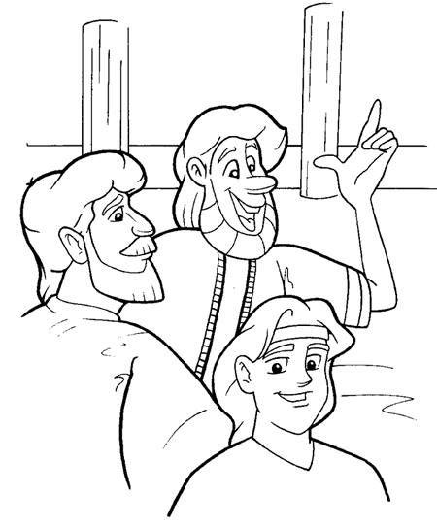

Every year Jewish Families would travel to Jerusalem to celebrate an important religious event, The Feast of the Passover. When Jesus was 12 years old, he and his parents set out for the festival as usual.
On their way home, Mary and Joseph noticed that Jesus was missing. At first they thought he must be with friends who where travelling with them. It was only after a day’s journey that they began to look for him.
Jesus was nowhere to be found. Mary was worried. “Where can he be?” she cried. “Something must have happened to him.”
Joseph comforted her. “We’ll find him,” he said. “Let’s go back to Jerusalem and look.”
For three days Mary and Joseph searched for Jesus. They were getting desperate. At last they went to the temple – and there he was sitting among a crowd of clever men, listening to them talking and asking questions. Everyone was astounded at the things Jesus knew and said.
Mary ran to Jesus and hugged him tightly. “Why did you do this to us?” she cried. “Your father and I have been very worried?”
“Why were you looking for me?” replied Jesus. “I was busy doing my Father’s work.”
Jesus went home with Mary and Joseph to Nazareth. He was a helpful, cheerful boy who always did as his parents asked. He learned to be a carpenter like Joseph and grew up to be a wise, kind man.

The Temple is a special place of worship for the Jews.
What special places do you know? Why are they special?
______________________________________________________________________________________________________________________________________________________________________________________________________________________________________________________________________________________________________________________________________________________________________________________________________________________________________________________________________________________________________________________________________________________________________
How do you think Mary and Joseph might have felt when
they couldn’t find Jesus?
______________________________________________________________________________________________________________________________________________________________________________________________________________________________________________________________________________________________________________________________________________________________________________________________________________________________________________________________________________________________________________________________________________________________________
What do you think Jesus meant when he said he was doing his Father’s work?
______________________________________________________________________________________________________________________________________________________________________________________________________________________________________________________________________________________________________________________________________________________________
Draw a picture of something that you have lost. How did you feel?

My Home

List in this box the things that you could not live without in your house, such as electricity, water, bath…
_____________________________________________________________________________________________________________________________________________________________________________________________________________________________________________________________________________________________________________

A home at the time of Jesus
When Jesus was a boy he lived in a small town called Nazareth. Between three and four thousand people lived there.
The poorer people lived in very simple houses. These were shaped like a square box. The walls were made of clay bricks held together with mud and lime cement. The roof was flat. It was made with the branches of trees. These houses were not very strong and the cement could be washed away by heavy rain and the roof blown away in storm.
Those families who could afford to build their houses of stronger materials, used stone for the walls and the branches on the roof were laid across wooden beams. Over the top of the branches they also put a thick layer of much which soon baked in the hot sun.
Inside most country houses there would be only one or maybe two rooms. There was very little furniture. People who lived in these houses kept their clothes and all their belongings in boxes or on shelves in the walls. They slept of mattresses which during the day were rolled up and stored away too.
Would you like to live in one of these houses? Why?
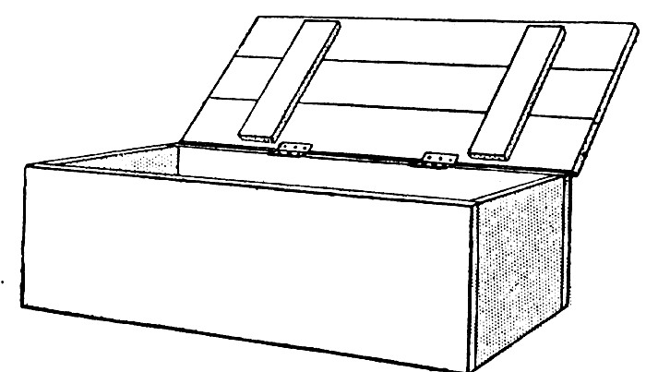
_______________________________________________________________________________________________________________________________________________________________________________________________________________________________________________________________________________________________________________________

Comparing Homes
Think about the differences between the house Jesus might have lived in as a boy and your house. Think about heating, cooking, building, windows, working, playing…
My House | Jesus’ House
Going to School
Where would Jesus have gone to school?
Who went to school in the time that Jesus lived?

What did the girls do?

What might Jesus have learned at school?

Why would Jesus have learned two languages?



This is a picture of Jesus at school…….
This is a picture of me at school…..
How does Jesus’ school differ from mine?

My school | Jesus’ school
Learning a Trade
What trade did Jesus learn to do? Why?

What do you want to be when you grow up? Why?


