The Wedding Party
WALT: To know the different members of the wedding party
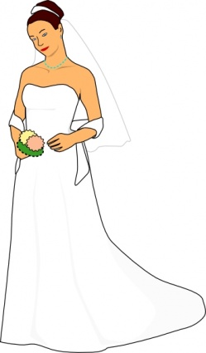 |  | 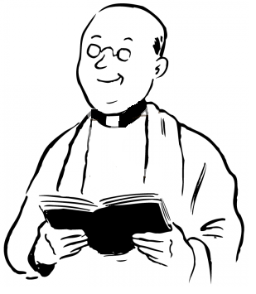 | 
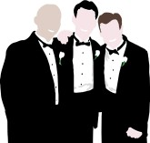 |  | 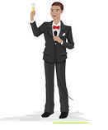 | 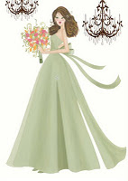
WILF: To use the pictures as clues to the members of the wedding party
bride | groom | vicar | bridesmaids
groomsmen | father of the bride | best man | matron of honour

groomsmen | father of the bride | best man | matron of honour
bride | groom | vicar | bridesmaids
groomsmen | father of the bride | best man | matron of honour
bride | groom | vicar | bridesmaids
groomsmen | father of the bride | best man | matron of honour
bride | groom | vicar | bridesmaids
groomsmen | father of the bride | best man | matron of honour
bride | groom | vicar | bridesmaids
The Wedding Party
Write down what each person does to prepare for the wedding celebrations
WALT: To know the different preparations of a wedding celebration
The Bride  ___________________________________  ___________________________________  ___________________________________  ___________________________________  _______________________________________________ | The Groom  _____________________________________  _____________________________________  _____________________________________  _____________________________________  _______________________________________________
The Best Man  ______________________________  ______________________________  ______________________________  ______________________________  ________________________________________________ | The Vicar  ______________________________  ______________________________  ______________________________  ______________________________  ________________________________________________
WILF: That each member of the wedding party has a different preparation
The Wedding Party
Write down what each person does to prepare for the wedding celebrations
WALT: To know the different preparations of a wedding celebration
The Bride  The brides organises the flowers, bridesmaids dresses and gets herself a special wedding dress which is traditionally white. The bride will work with the groom to organise the wedding party after the ceremony. | The Groom  The groom organises the special cars to get to the wedding and buys his and the best man’s suit. The groom will give a speech at the wedding party after the ceremony and sometimes organises the honeymoon.
The Best Man  The best man is in charge of looking after the wedding rings and the groom. He can also be in charge of the other members of the wedding party. He will make a speech at the wedding party after the ceremony. | The Vicar  The vicar gives the bride and groom guidance before they get married and says the prayers at the wedding ceremony. He wears a very special robe for the ceremony.
WILF: That each member of the wedding party has a different preparation

