LO: The fertilised seed becomes a seeds
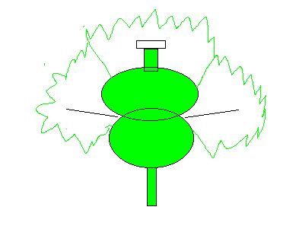
P _ _ _ _ _ die

Ovary contains S_ _ _ _ and becomes F_ _ _ _

- A flower dies and leaves behind a fruit with seeds.
- The ovary contains the seeds and becomes a fruit.

L.O: three ways to DISPERSE a fruit with it’s seeds.

Match these fruits with the correct type of seed dispersal.

WIND DISPERSAL
The fruits are light and feathery so they get blown by the wind.
Apple
Peas

Sycamore

CARRIED HEAVY SEEDS
The fruits are heavy, juicy. They get carried away by animals, ‘pooed’ out by animals. Sometimes when animals are full they get left.

EXPLOSION
The fruit skin (pod) dries up and splits open so it shoots out. These seeds are often collected by small animals such as mice.

