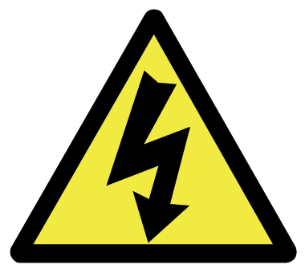
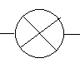

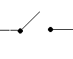
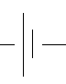
Electricity and Circuit Glossary.
Key words:
Battery – a power source. A battery is a container filled
with chemicals that produce electricity.
Conductor – a material that allows electricity to pass through easily.
Circuit – a path that allows electricity to flow through.
Insulator – a material that does not allow electricity to pass through it.

Mains – an electrical power source found in homes and other buildings.
Power source – the source of electrical power, can be a battery or mains.
Switch – a device which can control the flow of electricity.
Circuit Words

Cell or Battery
Bulb
Wires
Motor
Open Switch
Closed Switch
Complete Circuit
Gaps
Bulb Closed Switch Open Switch Cell or Battery Wire

